HerSafar
SPROJ Report



Muhammad Zain Naseer 26100378
Emaan Waleed 26100352
Muhammad 26100365
Maryam Rizwan 26100105
Kousar Pervaiz 26100405

Advisor: Waqar Ahmed
School of Science and Engineering
Lahore University of Management Sciences
Submission Date

Acknowledgement and Dedication

Certificate
I certify that the senior project titled “HerSafar” was completed under my supervision by the following students:

___________________________________________________________________
___________________________________________________________________
___________________________________________________________________

and the project deliverables meet the requirements of the program.

------------------------------------- Date:
Advisor (Signature)

------------------------------------- Date:
Co-advisor (if any)

Table of Contents
Table of Contents 5
List of Figures 9
1. Introduction 11
1.1 Objective and Scope 12
1.2 Development Methodology 12
1.3 Contributions 12
2. System Requirements 14
2.1 System Actors 14
2.2 Functional Requirements 15
Requirements of Commuter 15
Requirements of Driver 16
Requirements of Trusted Contacts of Commuter 16
Requirements of Admin 17
2.3 Non-functional Requirements 18
3. System Architecture 19
3.1 Architecture Diagram 20
3.2 Architecture Description 21
3.2.1 Frontend Layer 21
3.2.2 Security & Authentication Layer 21
3.2.3 API Gateway 22
3.2.4 Microservices Layer 22
3.2.5 AI & External Services Layer 24
3.2.6 Data Layer 24
a. Justification of the Architecture 26
b. Tools and Technologies 28
Frontend (Mobile Application) 28
Backend 28
Testing 29
DevOps and Deployment 29
Code Quality 30
Development Tools 30
4. Requirements Specifications 31
4.1 Use Cases 32
Book a Ride (Commuter) 32
Trigger SOS (Commuter) 33
Share Trip Details (Commuter) 34
Make Payment (Commuter/Driver) 35
Offer Ride (Driver) 36
Monitor Trip (Trusted Contacts) 37
Verify User Identity (Admin) 38
Send safety alerts (Admin) 39
Update Fares and Policies (Admin) 40
Send/Receive Voice Messages (Commuter) 40
4.2 Class Diagram 42
4.2.1 Class Descriptions 42
4.2.1.1 User 42
4.2.1.1.1 Purpose: 43
4.2.1.1.2 Attributes: 43
4.2.1.1.3 Methods: 43
4.2.1.2 TrustedContact 43
4.2.1.2.1 Purpose: 44
4.2.1.2.2 Attributes: 44
4.2.1.3 Driver 44
4.2.1.3.1 Purpose: 44
4.2.1.3.2 Attributes: 44
4.2.1.3.3 Methods: 44
4.2.1.4 VehicleInfo 45
4.2.1.4.1 Purpose: 45
4.2.1.5 PaymentAccounts 45
4.2.1.5.1 Purpose: 45
4.2.1.5.2 Attributes: 46
4.2.1.5.3 Methods: 46
4.2.1.6 RideRequest (In-Memory) 46
4.2.1.6.1 Purpose: 46
4.2.1.6.2 Attributes: 46
4.2.1.6.3 Methods: 46
4.2.1.7 Ride 47
4.2.1.7.1 Purpose: 47
4.2.1.7.2 Attributes: 47
4.2.1.7.3 Methods: 47
4.2.1.8 Payment 48
4.2.1.8.2 Attributes: 48
4.2.1.8.3 Methods: 48
4.2.1.9 Coupon 49
4.2.1.9.1 Purpose: 49
4.2.1.9.2 Attributes: 49
4.2.1.9.3 Methods: 49
4.2.1.10 FarePrice 49
4.2.1.10.1 Purpose: 49
4.2.1.10.2 Attributes: 50
4.2.1.10.3 Methods: 50
4.2.1.11 SafetyAlert 50
4.2.1.11.1 Purpose: 50
4.2.1.11.2 Attributes: 50
4.2.1.11.3 Methods: 50
4.2.1.12 UnsafeArea 51
4.2.1.12.1 Purpose: 51
4.2.1.12.2 Attributes: 51
4.2.1.12.3 Methods: 51
4.2.1.13 Policy 52
4.2.1.13.1 Purpose: 52
4.2.1.13.2 Attributes: 52
4.2.1.13.3 Methods: 52
4.2.1.14 SupportTicket 52
4.2.1.14.1 Purpose: 52
4.2.1.14.2 Attributes: 52
4.2.1.14.3 Methods: 53
4.2.1.15 OTP 53
4.2.1.15.1 Purpose: 53
4.2.1.15.2 Attributes: 53
4.3 Sequence Diagrams 54
1. Book a Ride (Commuter) 54
2. Cancel Ride (Commuter) 54
3. Trigger SOS (Commuter) 55
4. Send/Receive Voice Messages (Commuter) 56
5. Share Trip Details (Commuter) 57
6. Make Payment (Commuter/Driver) 58
7. Rate Ride (Commuter) 59
8. Verify User Identity 60
9. Send Safety Alerts (Admin) 62
10. Update Fares & Policies 62
5. Software Development Methodology and Plan 63
a. Software Process Selection 64
6. Database Design and Web Services 67
6.1 Database Design 67
Entity 1: users 69
Entity 2: drivers 70
Entity 3: rides 71
Entity 4: payments 73
Entity 5: supporttickets 74
Entity 6: safetyalerts 74
Entity 7: unsafeareas 75
Entity 8: coupons 76
Entity 9: fareprices 76
Entity 10: policies 77
6.2 API Specification 78
7. System User Interface 80
8. Project Security 90
9. Risk Management 92
Potential Risks and Mitigation Strategies 92
10. Testing and Evaluation 94
Testing Strategy 94
Sample Test Cases 94
11. Deployment Guidelines 96
11.1 Source Code 96
11.2 Prerequisites 96
11.3 Step 1 — Set GitHub Secrets 96
11.4 Step 2 — Configure Local Environment (Development Only) 97
11.5 Step 3 — Deploy to Production (Automated via CI/CD) 97
11.5.1 Stage 1 — CI (ci.yml): 98
11.5.2 Stage 2 — CD (cd.yml) (runs only if CI passes): 98
11.6 Step 4 — Verify Deployment 98
12. Conclusion 100
12.1 Summary 100
12.2 Challenges 100
12.3 Future 101
13. Review checklist 102
14. References 104

List of Figures

Introduction

HerSafar is a voice-first, Urdu-language ride-sharing mobile application designed specifically for female domestic workers in Pakistan. The name, Urdu for "her journey", reflects the application's central purpose: making daily commutes safer, more accessible, and less dependent on literacy or technical familiarity. HerSafar integrates Gemini-powered speech recognition and Google Cloud Text-to-Speech audio output, and a proactive safety alert system to provide an end-to-end ride-booking experience tailored to the needs of an underserved user population.
HerSafar is a transportation app. It falls in the same category as Uber or Careem, but it is designed for a group of users that those apps do not serve well: low-income women who may not be able to read or who are not comfortable using a smartphone. The app focuses on making ride-hailing simple, safe, and accessible for this group.
The main users of HerSafar are female domestic workers in Pakistani cities — women who travel daily between their homes and the homes where they work. Many of these women:
• Cannot read or have limited literacy
• Are not comfortable using apps that require a lot of typing or reading
• Face safety concerns when travelling alone, especially early in the morning or at night
• Have no access to a reliable, and safe transport option
Drivers registered on the platform are secondary users. Emergency contacts of commuters are also involved in the safety alert process.
HerSafar is a mobile app built using Flutter, targeting Android phones. It has three main parts: the mobile app that users interact with, a backend server built with Node.js and Express that handles all the logic and data, and a real-time system using Socket.IO for live ride tracking, safety alerts and similar features. The Gemini API is used to convert the user's voice to text and to read responses back to the user in Urdu audio.

1.1 Objective and Scope
The goal of HerSafar is to give female domestic workers a safe and easy way to book rides — something that existing apps like Uber and Careem do not provide for this group. Those apps were not built with low-literacy or first-time smartphone users in mind, which means many women are left relying on informal and often unsafe transport.
Specifically, HerSafar aims to:
- Remove the need for literacy by making the app fully voice-operated in Urdu
- Keep commuters safe through location tracking with trusted contacts during the ride
- Give users a way to report problems and have them resolved
• Build a platform that women can trust, with verified drivers and transparent processes

1.2 Development Methodology
HerSafar was built using Agile methodology, which means the work was divided into short development cycles called sprints. Each sprint focused on a specific set of features. This approach worked well for this project because many design decisions — especially around voice interaction and safety — changed as the team tested and got feedback.
The project was divided into five sprints. GitHub was used throughout to manage code and track changes.
Testing was done at multiple levels. Backend API tests were written using Jest and Supertest. A STRIDE framework was used, and security analysis was done through SonarQube using it to identify and address potential threats.

1.3 Contributions
Discuss the contributions of your work, highlighting the innovative aspects of your work. Discuss how your solution is better than other similar solutions.
HerSafar presents a context-aware redesign of ride-hailing systems specifically for female domestic workers in Pakistan, addressing critical gaps in accessibility, safety, affordability, ease of use, and reliability that exist in mainstream platforms such as inDrive, Careem, and Uber.
Existing digital transport apps are primarily English-intensive, text-heavy, and depend on reading, typing, and map-based navigation. For users with low literacy or limited English proficiency, these interfaces are difficult to use, effectively excluding them from digital mobility solutions that could improve their daily commuting experience. HerSafar directly addresses this gap by redesigning the interaction model around voice and simplicity.
Accessibility: The system introduces a fully voice-based interface in Urdu, removing the need for reading, typing, or English proficiency. This makes the platform usable for low-literacy users who are otherwise excluded from existing ride-hailing applications.
Safety: Safety is integrated into the core system through real-time location sharing, a trusted contact (“buddy”) system, continuous trip monitoring, and an SOS emergency feature. The SOS mechanism is designed with SMS fallback to ensure functionality even in low or no internet connectivity.
Affordability: HerSafar reduces commuting costs through optimized ride pricing and the introduction of discount coupons, allowing users to access subsidized rides and lowering overall travel expenses.
Ease of Use: The interface is designed to be simple and intuitive, requiring minimal digital literacy. Users can complete key actions such as booking rides, tracking trips, and triggering safety alerts through straightforward voice commands.
Reliability: The system ensures dependable performance through real-time updates and multi-channel communication (internet-based and SMS-based), ensuring continuity of service even in unstable network conditions.
Overall, HerSafar goes beyond incremental improvements to existing ride-hailing platforms by rethinking the system around the linguistic, economic, and safety constraints of its target users, making it more inclusive, practical, and context-appropriat

System Requirements
This chapter defines the system requirements for HerSafar. It begins by identifying the four actors who interact with the system — the Commuter, Driver, Trusted Contact, and Admin — along with a description of each actor's role. It then presents the functional requirements grouped by actor, capturing what each type of user needs the system to do. The chapter concludes with a set of non-functional requirements covering performance, availability, security, usability, and scalability constraints that the system must satisfy.

2.1 System Actors

Actor Name | Description
Commuter | Commuters are the main users of the application, typically female domestic workers and other vulnerable female groups. They use voice commands to find safe, affordable carpools, share their live location with trusted contacts, and access emergency safety features like SOS alerts.
Driver | Drivers are individuals offering rides along their daily routes. They interact with the system to register rides, receive optimized route suggestions, and collect secure payments through the app.
Trusted Contact | Trusted contacts are family members, friends, or guardians linked to a commuter account. They receive live trip updates, alerts, and SOS notifications to ensure the commuter’s safety during travel.
Admin | Admins manage the platform’s overall operations. They verify user profiles, monitor system activity, respond to SOS alerts, handle dispute resolution, and ensure the platform remains safe and trustworthy.

2.2 Functional Requirements

Requirements of Commuter
Sr# | Requirement
1 | I want to use the app through voice in Urdu so that I can complete registration, login, and email input without needing to read or type.
2 | I want to book rides and view available drivers on a map so that I can find safe and convenient transport options.
3 | I want to share my live trip details with trusted family members (buddy system) so that my family knows I am safe throughout the journey.
4 | I want a one-tap SOS emergency button during an active ride so that I can quickly alert my trusted contacts and admins in case of danger.
5 | I want to select a payment method (EasyPaisa, JazzCash, or cash) at the end of my ride so that my payment is recorded in the system.
6 | I want to apply discount coupons at payment time so that I can reduce my ride cost when promotional offers are available.
7 | I want to rate my driver after each ride so that I and other commuters can make informed, safe ride choices.
8 | I want to exchange text and voice messages with my driver during an active ride so that we can coordinate pickup without needing to share phone numbers.
9 | I want to view my full ride history so that I can review past trips, fares, and payment records.
10 | I want to submit a support ticket (with optional voice recording) if I face an issue so that I can get help from the platform.

Requirements of Driver
Sr# | Requirement
1 | I want to register on the platform by uploading my CNIC and driving licence so that I can be verified and start accepting rides.
2 | I want to receive ride requests in real time and accept or decline them so that I can manage my availability.
3 | I want to view the commuter's pickup and drop-off locations on a map so that I can navigate efficiently to complete the ride.
4 | I want my earnings to be recorded in the system after each ride so that I can track my income from the platform.
5 | I want to view my daily and total earnings so that I can track my income from the platform.
6 | I want to exchange text and voice messages with the commuter during an active ride so that we can coordinate without sharing personal contact details.
7 | I want to view my ride history and performance stats so that I can track my completed trips and average rating.

Requirements of Trusted Contacts of Commuter
Sr# | Requirement
1 | I want to receive real-time notifications when a commuter's ride starts or completes so that I can track their journey.
2 | I want to be alerted instantly with location details if the commuter triggers an SOS so that I can respond quickly or contact authorities.

Requirements of Admin
Sr# | Requirement
1 | I want to review and verify driver identity documents (CNIC and driving licence via OCR) so that only legitimate and trustworthy drivers are allowed on the platform.
2 | I want to add, update, suspend, or remove commuter and driver accounts so that the platform remains safe and free of bad actors.
3 | I want to monitor all ride payments (digital and earnings disbursements) so that transactions are transparent and disputes can be resolved fairly.
4 | I want to track all active rides in real time and receive fraud flags and anomaly alerts so that I can intervene quickly when suspicious behaviour is detected.
5 | I want to mark geographic areas as unsafe and set their severity and active duration so that commuters are warned before or during rides in those areas.
6 | I want to broadcast community-wide safety alerts with configurable severity and target audience (commuters, drivers, or all) so that users are informed about emerging risks.
7 | I want to view an analytics dashboard with ride statistics, revenue charts, user growth, and ride status distribution so that I can identify patterns and make data-driven decisions.
8 | I want to create and manage discount coupons (code, percentage, expiry, usage limits) so that I can run promotions on the platform.
9 | I want to update the per-kilometre fare rate so that pricing reflects current operating costs and regulations.
10 | I want to publish and manage platform policies with target audiences and expiry dates so that users are always informed of current rules.
11 | I want to view, respond to, and resolve support tickets submitted by commuters and drivers so that user issues are handled promptly.

2.3 Non-functional Requirements

Sr# | Requirement
1 | The voice recognition system (powered by Gemini AI) must achieve at least 85% accuracy when interpreting Urdu voice commands and extracting information such as email addresses and names under normal noise conditions.
2 | The system must process and respond to voice inputs (audio sent to Gemini for interpretation) within 6 seconds of audio submission on a 4G network connection.
3 | Battery consumption of the Flutter app must not exceed 10% per hour of active usage on a standard Android device with a 3000mAh battery.
4 | The system must maintain 99.5% uptime availability, measured monthly, excluding planned maintenance windows not exceeding 4 hours per month. Kubernetes rolling updates must ensure zero downtime during all production deployments.
5 | The backend must handle at least 100 concurrent active users (commuters and drivers) without degradation in API response time, supported by Kubernetes horizontal pod autoscaling.
6 | The application interface and voice-guided onboarding must be simple enough for users with minimal digital literacy to complete registration and book their first ride within 2 onboarding sessions, without needing to read any text.
7 | All API endpoints (except login and register) must require JWT authentication. Passwords must be hashed using bcrypt. All client-server communication must be encrypted via HTTPS. In-app chat messages must be end-to-end encrypted using session keys.
8 | The system must enforce Mongoose schema validation on all database writes and store all production secrets in Kubernetes Secrets — never in source code or Docker images — to prevent credential exposure.

System Architecture
HerSafar utilizes a Layered Microservices Architecture. The system is designed to decouple the frontend user experience from the complex backend logic, ensuring that mission-critical safety services remain operational even if other modules encounter issues

3.1 Architecture Diagram
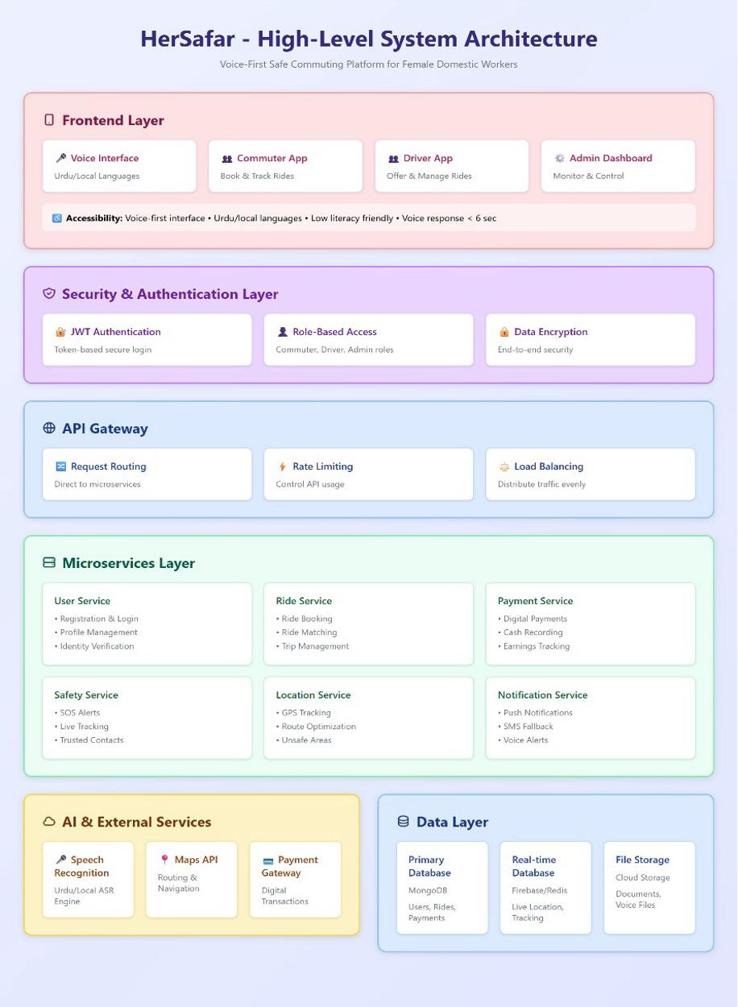

3.2 Architecture Description

3.2.1 Frontend Layer
The frontend layer delivers user interfaces designed specifically for each type of actor. This layer is designed around the core principles of the project: Accessibility, Voice-First interaction, and low digital literacy accommodation:
- Voice Interface: Serves as the main interaction channel with support for Urdu and other local languages. Handles voice commands for all user actions, removing the need for reading or typing. Utilizes speech-to-text for user input and text-to-speech for system feedback.
- Commuter App: Mobile application for female domestic workers to book rides, track trips, and access safety features. Includes large, easy-to-tap touch targets, minimal text, and voice-guided navigation designed for users with low digital literacy.
- Driver App: Mobile application enabling drivers to offer rides along their daily routes, manage earnings, and receive route optimization suggestions. Supports both voice and traditional input methods.
- Admin Dashboard: Administrative interface for system administrators to monitor operations, verify user identities, manage accounts, track real-time rides, update unsafe areas, and analyze system data.

3.2.2 Security & Authentication Layer
Provides comprehensive security controls across the entire system:
- JWT Auth: Token-based authentication using JSON Web Tokens for stateless, secure session management. Access tokens expire after 15 minutes; refresh tokens valid for 7 days.
- Role-Based Access: Implements RBAC (Role-Based Access Control) with four distinct roles (Commuter, Driver, Trusted Contact, Admin), each with specific permissions and access levels.
- Data Encryption: Enforces end-to-end encryption for sensitive data. TLS 1.3 for data in transit, AES-256 for stored data.. Voice messages and location data receive additional encryption layers.

3.2.3 API Gateway
Serves as the single entry point for all client requests, providing:
- Request Routing: Intelligent routing of API calls to appropriate microservices based on endpoint paths and request types.
- Rate Limiting: Protects the platform from abuse and ensures fair resource usage by restricting users to a maximum of 100 requests per minute. Different endpoints have customized rate limits depending on their computational or data intensity, preventing excessive load on critical services while maintaining smooth user experience for normal operations.
- Load Balancing: Distributes incoming traffic evenly across multiple instances of microservices to ensure optimal performance and prevent any single service from becoming overloaded..

3.2.4 Microservices Layer
Contains six core microservices, each with well-defined responsibilities:
User Service:
- Registration & Login: Handles new user signups with CNIC verification requirements and secure authentication
- Profile Management: Enables users to update personal information, and trusted contacts
- Identity Verification: Processes and validates CNIC and driving license documents submitted by users
Ride Service:
- Ride Booking: Allows commuters to match with available drivers based on ratings and personal preference.
- Trip Management: Tracks ride from booking through completion, handling status updates and modifications
Payment Service:
- Digital Payments: Processes transactions through JazzCash, EasyPaisa, and mobile wallets
- Cash Recording: Logs manually confirmed cash payments for record-keeping and driver earnings tracking
- Earnings Tracking: Maintains detailed payment history for drivers
Safety Service:
- SOS Alerts: Processes emergency triggers, immediately broadcasting location to trusted contacts and admin
- Trip Tracking: Monitors trip progress and keeps trusted contacts updated
- Trusted Contacts: Manages relationships between commuters and their designated emergency contacts
Location Service:
- GPS Tracking: Captures and stores real-time location coordinates during active trips
- Unsafe Areas: Maintains and queries database of flagged dangerous zones for route planning
Notification Service:
- Push Notifications: Sends real-time alerts via Firebase Cloud Messaging for trip updates and emergencies
- Voice Alerts: Provides spoken notifications in Urdu for important updates to accommodate low-literacy users

3.2.5 AI & External Services Layer
Integrates third-party services and AI capabilities. This layer operates horizontally alongside the Data Layer:
- Speech Recognition: The Gemini API processes user voice input and converts it to text with 85%+ accuracy for Urdu. Google Cloud Text-to-Speech handles audio output, reading system responses back to the user in Urdu.
- Maps API: Google Maps API provides routing, navigation, distance calculations, and geolocation services. Used by Location Service for route optimization.
- Payment Gateway: Integration with JazzCash and EasyPaisa APIs for secure digital transaction processing. Handles payment authorization, execution, and confirmation.

3.2.6 Data Layer
Persistent storage organized for optimal performance and scalability. This layer operates horizontally alongside the AI & External Services Layer:
Primary Database (MongoDB): MongoDB serves as the central data store for all persistent data. Unlike traditional relational databases, MongoDB's document-oriented structure naturally fits HerSafar's data model, particularly for:
- Nested structures: User profiles with embedded trusted contacts
- Geospatial queries: Finding rides near locations, detecting unsafe areas
- Flexible schema: Accommodating evolving requirements without migrations
- High write throughput: Handling frequent location updates during active trips
The database contains 10 main collections:
- Users: Core user profiles, authentication data, trusted contacts, and verification status
- Drivers: Extended driver information, vehicle details, payment accounts, and earnings
- Rides: Complete ride lifecycle data with embedded route coordinates and safety records
- Payments: Transaction records, coupon usage, commission breakdown, and payment history
- SupportTickets: Customer support requests submitted by commuters and drivers, with resolution tracking
- SafetyAlerts: Platform-wide emergency broadcasts sent by admins to commuters and/or drivers
- UnsafeAreas: Geospatial records of flagged dangerous zones used for route warnings
- Coupons: Promotional discount codes with usage limits, expiry dates, and redemption tracking
- FarePrices: Active fare configurations (rate per km) used to calculate ride costs
- Policies: Platform policies and announcements published by admins, with target audience and expiry
Real-time Database (Firebase/Redis): Provides low-latency storage for live location coordinates and active tracking sessions.
- Live location coordinates: GPS updates during active trips
- Active session tokens: JWT refresh tokens for fast validation
- Cache layer: Frequently accessed user profiles and ride status
Data automatically expires after trip completion.
File Storage (Cloud Storage): Stores binary files with encryption at rest:
- Verification documents: CNIC scans, driving licenses (JPEG/PNG/PDF)
- Voice messages: Encrypted audio recordings exchanged between users
File URLs are stored in MongoDB documents; actual files reside in cloud storage.

Justification of the Architecture
● Pros
Modular Microservices Design
- Each service (User, Ride, Payment, Safety, Location, Notification) operates independently
- Easy to update, scale, or fix individual services without affecting the entire system
3. Teams can work on different services simultaneously
Layered Architecture Approach
1. Clear separation of concerns (Frontend, Security, API Gateway, Services, Data)
- Easier to maintain and modify individual layers
3. Security layer centralized for consistent protection
Frontend Layer Separation
- Separate apps for different actors (Commuter, Driver, Admin) reduces complexity
- Each app can be optimized for specific user role
3. Easier to add new user types without affecting existing apps
Dedicated Safety Service
1. Mission-critical feature isolated from other services
- Can be prioritized for resources and uptime
3. Faster response time for emergency features (SOS)
Separation of External Services Layer
1. Third-party integrations (Maps, Payment, Speech) isolated
- Easy to swap providers without affecting core services

● Cons
Network Latency
1. Service-to-service communication over network adds latency
- Multiple hops (Frontend → API Gateway → Service → Database) increase response time
3. Not suitable for sub-millisecond response requirements
Operational Overhead
1. Need for container orchestration (Kubernetes/Docker)
- Multiple deployment pipelines for each service
3. Requires DevOps expertise and infrastructure monitoring tools
Multiple External Dependencies
1. Reliance on third-party services (Speech Recognition, Maps API, Payment Gateway) creates vulnerability
- Service outages or API changes from external providers can break functionality
3. Ongoing subscription costs for multiple external services
Resource Intensive
1. Each microservice requires separate computing resources (CPU, memory)
2. Higher infrastructure costs compared to monolithic architectData Consistency Challenges
1. Maintaining data consistency across 6 different microservices is complex
- Real-time updates between services can lead to temporary inconsistencies
3. Rollback operations in case of failures affect multiple services

Tools and Technologies

Frontend (Mobile Application)
The mobile client was built using Flutter with Dart.

Package | Version | Purpose
Flutter | 3.41.2 (Dart SDK 3.11.0) | Cross-platform mobile application framework
google_maps_flutter | 2.14.0 | Live map display and ride tracking
socket_io_client | 3.1.4 | Real-time communication with the backend for live tracking and alerts
flutter_tts | 4.2.5 | Text-to-speech output for Urdu audio responses and safety prompts
speech_to_text | 7.3.0 | Captures and converts user voice input to text
geolocator | 14.0.2 | Retrieves the user's current GPS location
provider | 6.1.5+1 | State management
fl_chart | 1.1.1 | Charts and graphs for the system analytics dashboard

Backend
The backend was built using Node.js and Express, with MongoDB as the database.

Package | Version | Purpose
Node.js | 22.18.0 | JavaScript runtime environment for the backend server
Express.js | 5.1.0 | Web framework for building the REST API
MongoDB Atlas | Cloud (v7.0) | Cloud-hosted NoSQL database
Mongoose | 8.19.2 | MongoDB object modelling for Node.js
Socket.IO | 4.8.1 | Real-time bidirectional communication for live tracking and safety alerts
jsonwebtoken | 9.0.2 | User authentication via JSON Web Tokens
bcryptjs | 3.0.2 | Secure password hashing
@google/genai | 1.26.0 | Google Gemini API SDK for speech-to-text and text-to-speech in Urdu
cloudinary | 2.8.0 | Cloud-based image storage and delivery for profile photos
nodemailer | 7.0.12 | Sends transactional emails such as OTPs and notifications
express-rate-limit | 8.2.1 | Rate limiting to protect the API against abuse
winston | 3.18.3 | Server-side logging of events and errors

Testing
The following tools were used for automated and manual testing of the backend:

Tool | Version | Purpose
Jest | 30.2.0 | Unit testing framework for the Node.js backend
Supertest | 7.2.2 | HTTP endpoint testing for the REST API
Postman | Latest | Manual API testing and endpoint verification

DevOps and Deployment
The backend was containerised using Docker and deployed using Kubernetes for container orchestration. GitHub was used for version control throughout the project.

Tool | Version | Purpose
Docker | 28.3.3 | Containerisation of the backend application
Kubernetes | 1.32.2 | Container orchestration and deployment management
GitHub | N/A | Version control and branch management

Code Quality
The following tools were used to maintain code consistency and quality across the codebase:

Tool | Version | Purpose
ESLint | ^9.36.0 | Static code analysis and linting for the backend
Prettier | ^3.6.2 | Automated code formatting
Husky | ^9.1.7 | Git hooks to enforce linting and formatting before commits
flutter_lints | ^5.0.0 | Recommended lint rules for the Flutter codebase

Development Tools

Tool | Version | Purpose
Figma | Latest | UI/UX design and prototyping
Visual Studio Code | Latest | Primary code editor
Android Studio | Hedgehog (2023.1.1) | Android emulator and Flutter debugging

Requirements Specifications
This chapter presents the requirements specifications for HerSafar through a set of standard UML models. It begins with use case diagrams that identify the main actors in the system — the commuter, driver, trusted contact, and admin — and the interactions each actor has with the system. This is followed by detailed descriptions of ten core use cases, each outlining the purpose, preconditions, postconditions, and typical, alternate, and exception flows. The chapter then presents a class diagram describing the structure of the system and the relationships between its core entities. Finally, sequence diagrams are provided for each of the ten use cases, illustrating the step-by-step flow of messages and interactions between system components.

4.1 Use Cases
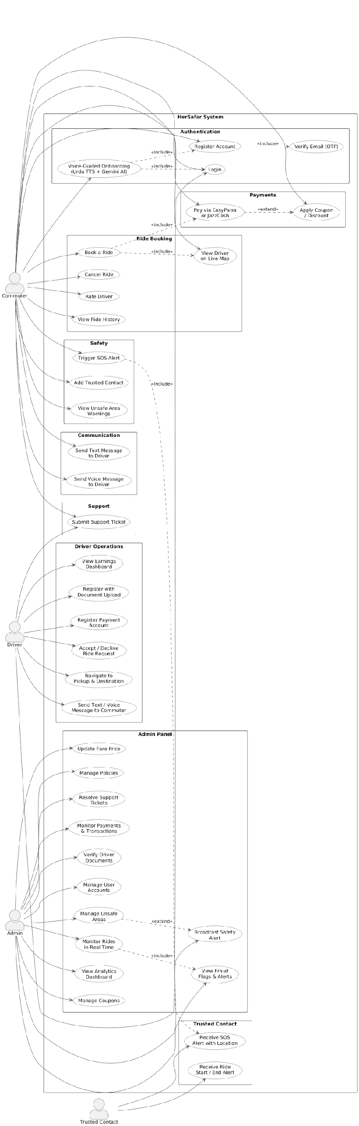

Book a Ride (Commuter)
Identifier | UC-001
Purpose | The commuter uses voice commands in Urdu to search and book a safe carpool ride.
Pre-conditions | User is registered and logged in. Location access enabled.
Post-conditions | Ride is confirmed and trip details are shared with trusted contacts.
Step # | Typical Course of Action
1 | Commuter opens the app and navigates to the ride booking screen.
2 | Commuter states the destination by voice in Urdu.
3 | The system sends the recorded audio to Gemini AI, which extracts the destination name and initiates a search for available drivers.
4 | System displays available ride matches to the commuter.
5 | Commuter selects and confirms a ride.
Step # | Alternate Courses of Action
5 | If the commuter declines the suggested ride, the system returns to the home screen.
2 | Commuter may also type the destination manually using the text input field instead of voice.
Step # | Exception Paths
3 | If Gemini AI fails to extract a valid destination from the voice input, the booking is not initiated and the commuter may try again.

Trigger SOS (Commuter)

Identifier | UC-002
Purpose | Allow the commuter to alert trusted contacts and administrators in case of an emergency.
Pre-conditions | Trip is currently active. Location access enabled.
Post-conditions | SOS alert sent to trusted contacts and admin with live GPS location.
Step # | Typical Course of Action
1 | Commuter presses the SOS button in the app.
2 | System immediately sends SOS alerts to all linked trusted contacts and admin, including the commuter's live GPS location.
3 | Admin receives the alert and may escalate to local authorities if required.
Step # | Exception Paths
1 | If the SOS request fails due to a network error, the system displays an error dialog and resets the SOS button so the commuter can attempt to send the alert again.

Share Trip Details (Commuter)

Identifier |  | UC-003
Purpose |  | Keep trusted contacts informed about the commuter’s trip, including start, route, and live location.
Pre-condit ions |  | ● Commuter has linked trusted contacts.  ● Trip has started.  ● Location access and network connectivity are enabled.
Post-condi tions |  | ● Trusted contacts receive notifications about trip start, route, and live location.  ● Contacts are kept updated throughout the trip unless they opt out.
Step # | Typical Course of Action
1. | Trip begins.
2. | System automatically notifies all linked trusted contacts with trip start, route, and live location updates.
3. | System continues to send periodic location updates and route progress to contacts until the trip ends or the commuter cancels sharing.
Step # | Alternate Courses of Action
2. | If a trusted contact chooses to stop receiving updates, the system stops sending notifications to that contact.
Step # | Exception Paths
1. | If location services are disabled on the commuter’s device, the system notifies the commuter and aborts sharing trip details until location is enabled.
2. | If network or system failure prevents sending updates, the system retries automatically and logs failures.

Make Payment (Commuter/Driver)

Identifier |  | UC-004
Purpose |  | Allow the commuter to select a payment method for a completed ride and ensure the transaction is recorded in the system.
Pre-condit ions |  | ● Ride has been completed.  ● Network connectivity is enabled for digital payments.
Post-condi tions |  | ● Payment is successfully logged in the system.  ● Driver is credited for the ride.  ● Payment history is updated for both commuter and driver.
Step # | Typical Course of Action
1. | Commuter selects a payment option (digital or cash).
2. | Commuter selects a payment method (EasyPaisa, JazzCash, or cash). The system records the selection and logs the transaction.
3. | System records the transaction, updates payment history, and notifies both commuter and driver of successful payment.
Step # | Alternate Courses of Action
2. | If digital payment fails (e.g., insufficient balance, network issue), the system prompts the commuter to fallback to cash payment.
Step # | Exception Paths
2. | If payment processing times out or fails repeatedly, the system retries  automatically. If retries fail, the system notifies the commuter and driver, marks the payment as failed, and prompts the commuter to retry the payment manually or choose an alternate payment method.

Offer Ride (Driver)

Identifier |  | UC-005
Purpose |  | Allow verified drivers to post ride availability, enabling commuters to view and book rides.
Pre-condit ions |  | ● Driver is verified and logged in.  ● Vehicle information and route details are available.
Post-condi tions |  | ● Ride is listed in the system for matching with commuters. ●System suggests the optimal, safe route for the driver.
Step # | Typical Course of Action
1. | Driver posts ride details including origin, destination, time, and vehicle info.
2. | System analyzes the route and suggests an optimized and safe path.
3. | Ride listing goes live and is available for commuters to book.
Step # | Alternate Courses of Action
2. | If the posted route is flagged as unsafe, the system suggests an alternative safe route for the driver.
Step # | Exception Paths
1. | If required ride details (e.g., origin, destination, time) are missing or invalid, the system rejects the posting and prompts the driver to provide complete information.

Monitor Trip (Trusted Contacts)

Identifier |  | UC-006
Purpose |  | Allow trusted contacts to monitor the commuter’s trip progress and location for safety purposes.
Pre-condit ions |  | ● Commuter has linked trusted contacts in the system.  ● Trip is active.  ● Location access and network connectivity are enabled.
Post-condi tions |  | ● Trusted contacts are updated about the commuter’s trip status. ● Live tracking is available until trip completion.
Step # | Typical Course of Action
1. | Trip begins, and system sends notification to trusted contact.
2. | Trusted contact opens the app (or SMS link) to view commuter’s trip details and live location.
3. | System continues to update contact with trip progress in real-time.
Step # | Alternate Courses of Action
1. | If the trusted contact is offline, trip status and updates are sent via SMS.
Step # | Exception Paths
1. | If the commuter disables trip sharing, the trusted contact cannot view trip updates and is notified accordingly.

Verify User Identity (Admin)

Identifier |  | UC-007
Purpose |  | Ensure only trusted users are approved for the platform.
Pre-condit ions |  | User has applied for an account and submitted required documents (CNIC/license).
Post-condi tions |  | User is either approved or rejected based on verification.
Step # | Typical Course of Action
1. | Admin reviews the submitted CNIC/license.
2. | Admin cross-checks the details with the database/official records.
3. | Admin approves or rejects the user’s account.
Step # | Alternate Courses of Action
1. | If the documents are unclear or incomplete, the admin requests resubmission from the user.
Step # | Exception Paths
3. | If documents are found to be forged, the system suspends the user’s account and flags it for investigation.

Send safety alerts (Admin)

Identifier |  | UC-008
Purpose |  | Alert commuters and drivers about urgent safety risks.
Pre-condit ions |  | ● Admin logged in.  ● Threat identified (e.g., strike, road closure).
Post-condi tions |  | ● Users notified with alert. ● Trips adjusted if needed.
Step # | Typical Course of Action
1. | Admin drafts alert message.
2. | System sends push notification to all affected users.
Step # | Alternate Courses of Action
2. | For critical threats, system initiates automated voice call alerts.
Step # | Exception Paths
2. | If push delivery fails, system retries or sends SMS fallback.

Update Fares and Policies (Admin)

Identifier |  | UC-009
Purpose |  | Enable admin to adjust fare rules and platform policies.
Pre-condit ions |  | ● Admin logged in.  ● Existing fare and policy structure available.
Post-condi tions |  | ● Updated fares/policies visible in the app. ● Future rides use new structure.
Step # | Typical Course of Action
1. | Admin opens fare/policy settings.
2. | Admin updates values or terms.
3. | System applies changes and logs update.
Step # | Alternate Courses of Action
3. | Instead of immediate application, system schedules changes to take effect at midnight to avoid confusion during active rides.
Step # | Exception Paths
3. | Invalid or incomplete entry rejected by system, with admin prompted to correct.

Send/Receive Voice Messages (Commuter)

Identifier |  | UC-010
Purpose |  | Allow commuters to communicate via voice messages without typing, ensuring accessibility and convenience.
Pre-condit ions |  | ● User is logged in.  ● App has permission to access microphone.
Post-condi tions |  | ● Voice message is delivered securely to the recipient. ●Recipient is notified of the incoming message.
Step # | Typical Course of Action
1. | Commuter records a voice note using the app.
2. | System encrypts the message and sends it to the recipient.
3. | Recipient can play the voice message.
Step # | Alternate Courses of Action
2. | If internet connection is weak, the system stores the message locally and forwards it automatically once the connection becomes stable.
Step # | Exception Paths
2. | If the message file is corrupted during recording or transmission, the system prompts a resend to ensure successful delivery.

4.2 Class Diagram
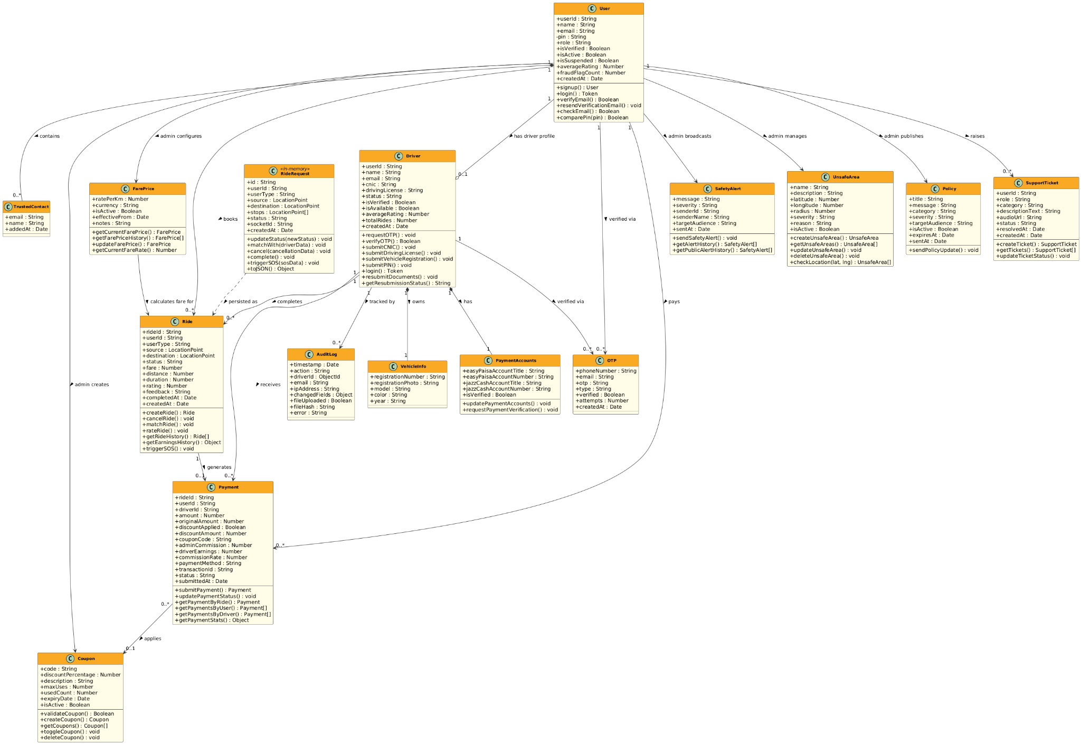

4.2.1 Class Descriptions

4.2.1.1 User

4.2.1.1.1 Purpose:
Represents any registered account on the platform. A single role field differentiates commuters, drivers, and admins ,there is no inheritance hierarchy. Stores credentials, trusted contacts, account status, fraud flags, and rating data

4.2.1.1.2 Attributes:
userId (String): Unique system-generated identifier.
name (String): Full name of the user.
email (String): Login email address.
pin (String): Bcrypt-hashed 4-digit PIN used for authentication.
role (String): Account type — commuter, driver, or admin.
isVerified (Boolean): Whether the email has been verified.
isActive / isSuspended (Boolean): Account status flags managed by admin.
averageRating (Number): Computed average of all received ratings.
fraudFlagCount (Number): Number of fraud reports raised against this user.
createdAt / lastLogin (Date): Registration and last activity timestamps.

4.2.1.1.3 Methods:
signup(): Registers a new commuter account and sends a verification email.
login(): Authenticates user by email and PIN, returns a JWT token.
verifyEmail(): Confirms the account using the emailed verification token.
resendVerificationEmail(): Re-sends the verification link if expired.
checkEmail(): Checks whether an email is already registered.
comparePin(pin): Compares a plain-text PIN against the stored bcrypt hash.

4.2.1.2 TrustedContact

4.2.1.2.1 Purpose:
An embedded sub-document stored inside the User document. Represents a person the commuter has linked for safety monitoring. Trusted contacts receive SOS alerts and ride start/end notifications via email. They are not registered users of the platform.

4.2.1.2.2 Attributes:
email (String): Email address of the trusted contact.
name (String): Display name of the contact.
addedAt (Date): Timestamp when the contact was added by the commuter.

4.2.1.3 Driver

4.2.1.3.1 Purpose:
Represents a driver's profile on the platform. Created separately from the User document during a multi-step OTP-based registration flow. Tracks verification status, vehicle details, wallet accounts, and an admin-managed approval history.

4.2.1.3.2 Attributes:
userId (String): Links this driver profile to the corresponding User document.
cnic (String): National ID number submitted during registration.
drivingLicense (String): Driving licence number submitted during registration.
status (String): Admin-controlled state — pending, approved, rejected, resubmission_required, or suspended.
isAvailable (Boolean): Whether the driver is currently accepting ride requests.
averageRating / totalRides (Number): Performance metrics updated after each completed ride.

4.2.1.3.3 Methods:
requestOTP(): Sends an OTP to the driver's email to begin registration.
verifyOTP(): Validates the OTP and issues a registration token.
submitCNIC(): Submits the CNIC number in the registration flow.
submitDrivingLicense(): Submits the driving licence number.
submitVehicleRegistration(): Submits vehicle details and registration photo.
submitPIN(): Sets the driver's login PIN to complete registration.
login(): Authenticates the driver and returns a JWT token.
resubmitDocuments(): Allows re-upload of documents when admin requests resubmission.
getResubmissionStatus(): Retrieves current resubmission notes from admin.

4.2.1.4 VehicleInfo

4.2.1.4.1 Purpose:
Embedded sub-document within the Driver document. Stores all details about the driver's vehicle including a photo of the registration document.
Attributes:
registrationNumber (String): Vehicle registration plate number.
registrationPhoto (String): URL of the uploaded vehicle registration image.
model (String): Vehicle model name.
color (String): Vehicle colour.
year (String): Year of manufacture.

4.2.1.5 PaymentAccounts

4.2.1.5.1 Purpose:
Embedded sub-document within the Driver document. Stores the driver's EasyPaisa and JazzCash mobile wallet details for receiving digital payments from commuters. Accounts require admin verification before use.

4.2.1.5.2 Attributes:
easyPaisaAccountTitle / easyPaisaAccountNumber (String): EasyPaisa wallet details.
jazzCashAccountTitle / jazzCashAccountNumber (String): JazzCash wallet details.
isVerified (Boolean): Whether the account has been verified by admin.

4.2.1.5.3 Methods:
updatePaymentAccounts(): Driver updates their wallet account details.
requestPaymentVerification(): Driver requests admin to verify their wallet account.

4.2.1.6 RideRequest (In-Memory)

4.2.1.6.1 Purpose:
A plain JavaScript class that lives in the Socket.IO server's memory during an active ride session. Holds real-time state including live locations, socket IDs, match information, and SOS data. Not persisted to MongoDB. When the ride ends, its data is written to the Ride collection.

4.2.1.6.2 Attributes:
id (String): UUID assigned at creation.
userId (String): Commuter or driver who created the request.
source / destination (LocationPoint): Pick-up and drop-off addresses with coordinates.
stops (LocationPoint[]): Optional intermediate stops along the route.
status (String): Current state — pending, matched, cancelled, or completed.
socketId (String): Active Socket.IO connection identifier.

4.2.1.6.3 Methods:
updateStatus(newStatus): Changes the ride state.
matchWith(driverData): Links the ride to an accepting driver.
cancel(cancellationData): Records cancellation reason and updates state.
complete(): Marks the ride as finished.
triggerSOS(sosData): Attaches SOS alert data including GPS location and timestamp.
toJSON(): Serialises the object for Socket.IO event payloads.

4.2.1.7 Ride

4.2.1.7.1 Purpose:
The MongoDB-persisted record of a ride. Created when a ride ends (completed or cancelled). Used for ride history, earnings tracking, ratings, analytics, and SOS audit trails.

4.2.1.7.2 Attributes:
rideId (String): Unique ride identifier.
source / destination (LocationPoint): Route endpoints with addresses and coordinates.
status (String): Final status — pending, matched, cancelled, or completed.
fare (Number): Total fare in PKR.
distance (Number): Trip distance in kilometres.
duration (Number): Trip duration in minutes.
rating (Number): Commuter's post-ride rating of the driver (1–5).
sosAlert (Object): Embedded SOS data if triggered during the ride.
completedAt / createdAt (Date): Ride lifecycle timestamps.

4.2.1.7.3 Methods:
createRide(): Persists a new ride record.
cancelRide(): Records cancellation with reason and cancelled-by party.
matchRide(): Saves matched driver information to the ride record.
rateRide(): Stores post-ride rating and feedback, updates driver average.
getRideHistory(): Returns paginated ride history for a user or driver.
getEarningsHistory(): Returns driver earnings grouped by date.
triggerSOS(): Records SOS event with GPS coordinates and timestamp.

4.2.1.8 Payment
4.2.1.8.1 Purpose:
Records a financial transaction for a completed ride. Supports three payment methods — EasyPaisa, JazzCash, and cash. Stores the platform's commission split (20% admin, 80% driver) and any discounts or coupon deductions applied.

4.2.1.8.2 Attributes:
rideId / userId / driverId (String): Links payment to the relevant ride and parties.
amount (Number): Final amount paid by commuter in PKR.
originalAmount (Number): Pre-discount fare.
discountApplied (Boolean): Whether a first-ride discount was applied.
couponCode / couponDiscountAmount (String/Number): Coupon details if used.
adminCommission / driverEarnings (Number): Split of the total fare.
commissionRate (Number): Platform commission percentage (default 20%).
paymentMethod (String): easypaisa, jazzcash, or cash.
transactionId (String): Digital wallet reference number (null for cash).
status (String): pending, verified, or rejected.

4.2.1.8.3 Methods:
submitPayment(): Commuter submits payment proof after ride completion.
updatePaymentStatus(): Admin verifies or rejects a payment.
getPaymentByRide(): Fetches the payment record for a specific ride.
getPaymentsByUser(): Returns commuter payment history.
getPaymentsByDriver(): Returns driver earnings history.
getPaymentStats(): Aggregates payment totals for analytics.

4.2.1.9 Coupon

4.2.1.9.1 Purpose:
An admin-created discount code that commuters can apply at payment time. Supports usage limits, expiry dates, and toggling active status without deletion.

4.2.1.9.2 Attributes:
code (String): Unique uppercase coupon code.
discountPercentage (Number): Percentage discount to apply (1–100).
maxUses (Number): Maximum number of times the coupon can be used (null = unlimited).
usedCount (Number): Running count of how many times it has been applied.
expiryDate (Date): Expiry timestamp (null = no expiry).
isActive (Boolean): Whether the coupon can currently be applied.

4.2.1.9.3 Methods:
validateCoupon(): Checks if a code is valid, active, and within usage limits.
createCoupon(): Admin creates a new coupon.
getCoupons(): Returns all coupons with current usage stats.
toggleCoupon(): Activates or deactivates a coupon without deleting it.
deleteCoupon(): Permanently removes a coupon.

4.2.1.10 FarePrice

4.2.1.10.1 Purpose:
Stores the platform's current per-kilometre fare rate in PKR. Only one record is active at a time. Admin can update the rate and previous rates are retained for historical reference.

4.2.1.10.2 Attributes:
ratePerKm (Number): Active fare rate in PKR per kilometre (default 18).
currency (String): Always PKR.
isActive (Boolean): Flags the currently effective rate.
effectiveFrom (Date): When this rate came into effect.
notes (String): Admin notes explaining the rate change.

4.2.1.10.3 Methods:
getCurrentFarePrice(): Returns the currently active fare record.
getFarePriceHistory(): Returns all historical fare records.
updateFarePrice(): Admin sets a new active rate and deactivates the old one.
getCurrentFareRate(): Static method returning just the numeric rate value.

4.2.1.11 SafetyAlert

4.2.1.11.1 Purpose:
An admin-broadcast safety message sent to all users, only drivers, or only commuters. Used to warn about security threats, road closures, or urgent platform-wide incidents.

4.2.1.11.2 Attributes:
message (String): Alert text content.
severity (String): Risk level — low, medium, high, or critical.
senderId / senderName (String): Admin who sent the alert.
targetAudience (String): Recipients — all, drivers, or commuters.
sentAt (Date): Timestamp of broadcast.

4.2.1.11.3 Methods:
sendSafetyAlert(): Admin broadcasts an alert to the target audience via Socket.IO.
getAlertHistory(): Returns full alert history for admin review.
getPublicAlertHistory(): Returns recent alerts visible to commuters and drivers.

4.2.1.12 UnsafeArea

4.2.1.12.1 Purpose:
A geo-fenced zone marked as unsafe by admin based on incident reports. Each area has a centre point, radius, and severity. The system checks route coordinates against active unsafe areas and warns users whose routes pass through them.

4.2.1.12.2 Attributes:
name (String): Location name.
description (String): Explanation of the risk.
latitude / longitude (Number): Centre coordinates of the zone.
radius (Number): Affected radius in metres (minimum 100 m).
severity (String): warning (alert but allow) or blocked (prevent routing through).
reason (String): Nature of the hazard.
isActive (Boolean): Whether the zone is currently enforced.
activeFrom / activeTo (Date): Optional time-bound restrictions.

4.2.1.12.3 Methods:
createUnsafeArea(): Admin defines a new unsafe zone.
getUnsafeAreas(): Returns all active or all unsafe areas.
updateUnsafeArea(): Admin edits zone details or adjusts boundaries.
deleteUnsafeArea(): Removes a zone permanently.
checkLocation(lat, lng): Checks whether given coordinates fall within any active unsafe zone using the Haversine formula.

4.2.1.13 Policy

4.2.1.13.1 Purpose:
An admin-published policy update, announcement, or terms change broadcast to a specific user group. Can have an expiry date after which it becomes inactive.

4.2.1.13.2 Attributes:
title (String): Headline of the policy.
message (String): Full policy text.
category (String): Type — general, safety, pricing, terms, or privacy.
severity (String): Importance level — low, medium, high, or critical.
targetAudience (String): all, drivers, or commuters.
isActive (Boolean): Whether the policy is currently in effect.
expiresAt (Date): Auto-deactivation timestamp (null = permanent).

4.2.1.13.3 Methods:
sendPolicyUpdate(): Admin publishes a policy and pushes it to users via Socket.IO.

4.2.1.14 SupportTicket

4.2.1.14.1 Purpose:
A complaint or report raised by a commuter or driver. Supports both text descriptions and audio recordings (for accessibility). Admin manages and resolves tickets through the admin dashboard.

4.2.1.14.2 Attributes:
userId (String): User who raised the ticket.
role (String): Whether the submitter is a commuter or driver.
category (String): Issue type — safety_concern, payment_issue, behavior_complaint, or app_bug.
descriptionText (String): Written description of the issue.
audioUrl (String): URL of an uploaded voice recording describing the issue.
status (String): Ticket state — open, in_progress, or resolved.
resolvedAt (Date): Timestamp when admin marked it resolved.

4.2.1.14.3 Methods:
createTicket(): Submits a new support ticket with text or audio.
getTickets(): Admin retrieves all tickets, optionally filtered by status.
updateTicketStatus(): Admin changes ticket status and records resolver details.

4.2.1.15 OTP

4.2.1.15.1 Purpose:
A temporary one-time password used during driver registration and user password-reset flows. Automatically deleted by a MongoDB TTL index 10 minutes after creation, so no manual cleanup is required.

4.2.1.15.2 Attributes:
phoneNumber / email (String): The identity the OTP was issued to (at least one required).
otp (String): The one-time code.
type (String): Context — driver_registration, user_registration, password_reset, or phone_verification.
verified (Boolean): Whether the OTP has already been used.
attempts (Number): Number of failed verification attempts.
createdAt (Date): Creation timestamp; TTL index expires the document after 600 seconds

4.3 Sequence Diagrams

1. Book a Ride (Commuter)

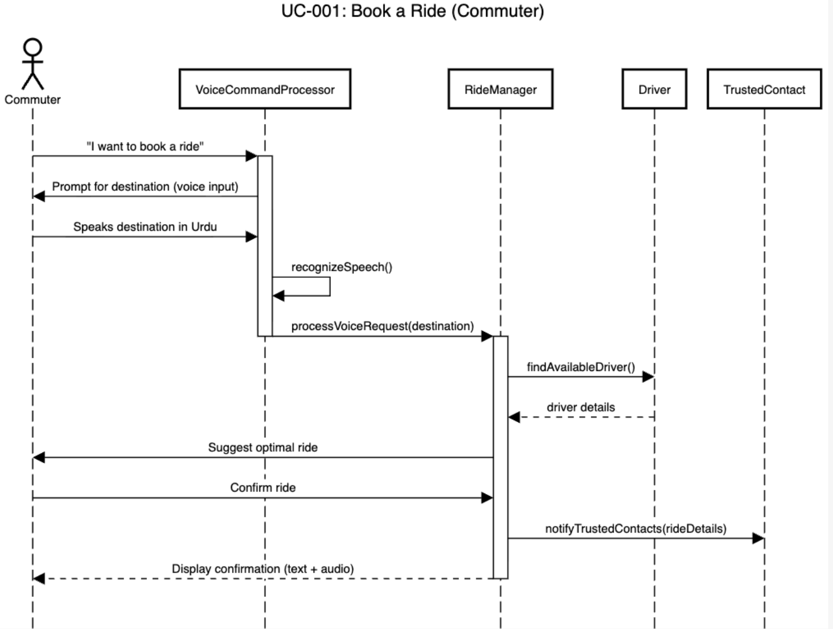

2. Cancel Ride (Commuter)

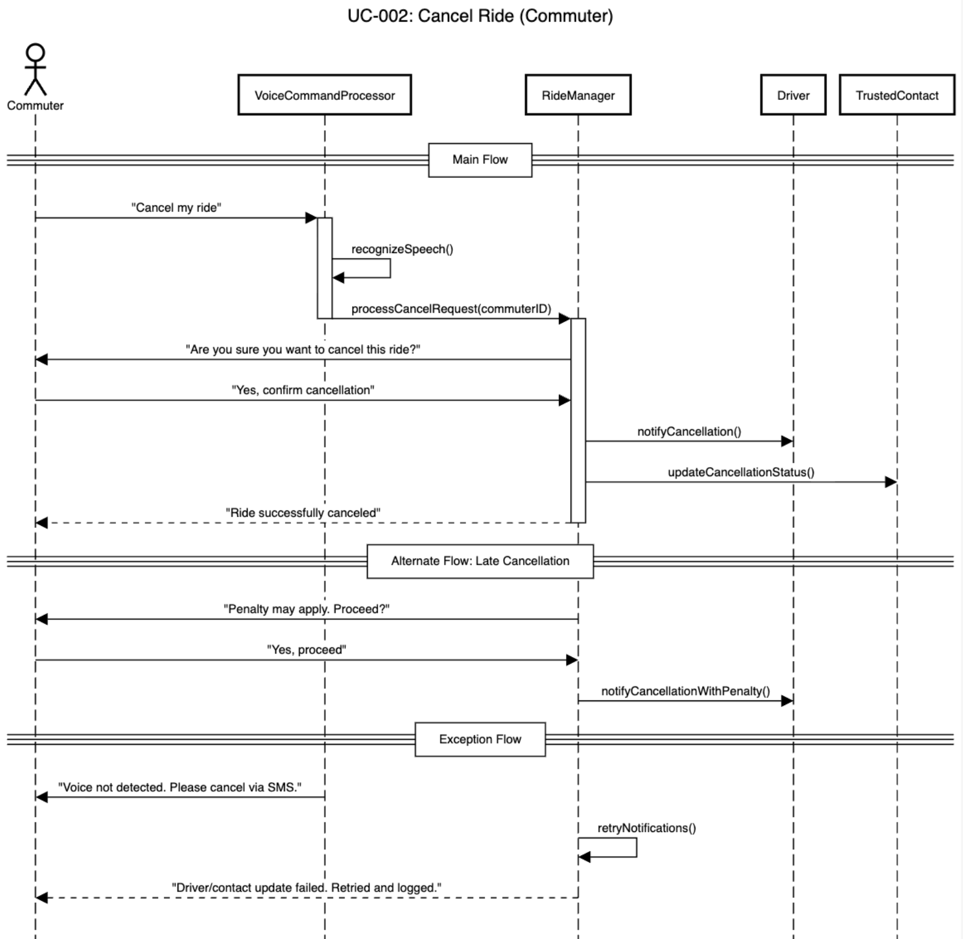

3. Trigger SOS (Commuter)

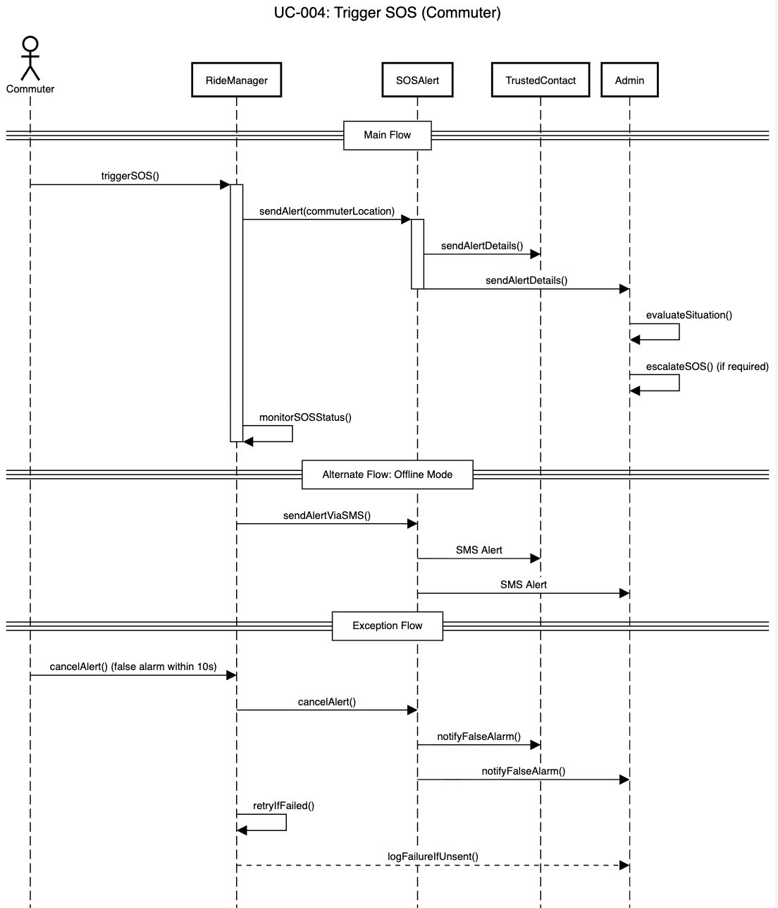

4. Send/Receive Voice Messages (Commuter)

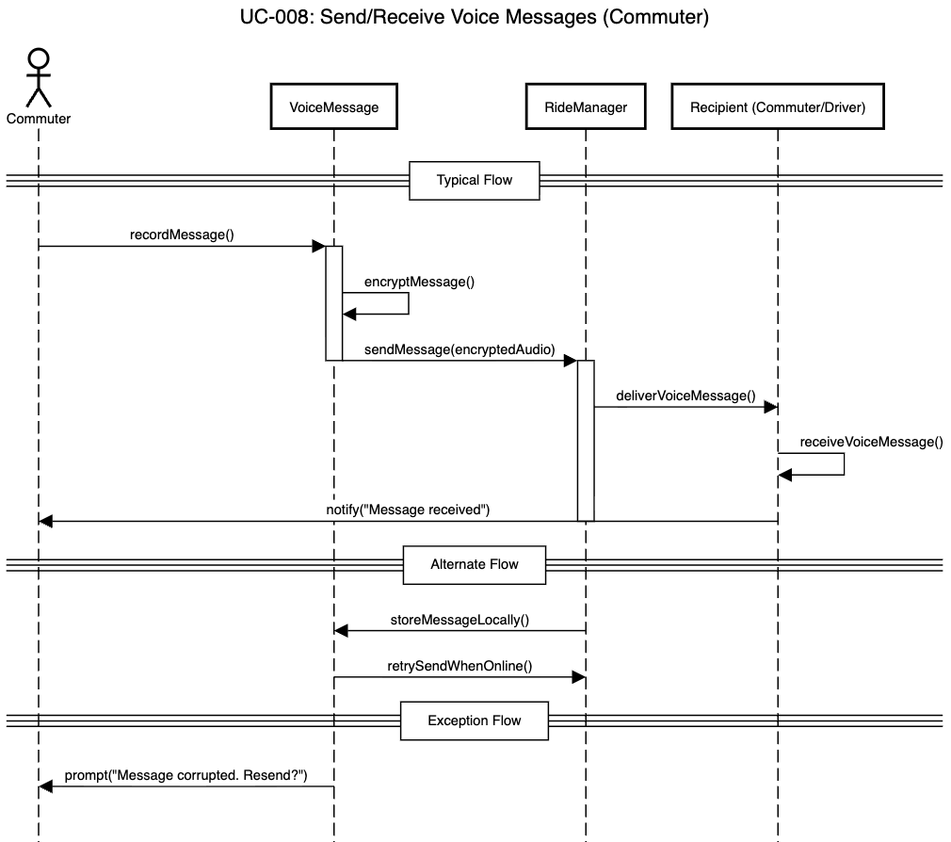

5. Share Trip Details (Commuter)

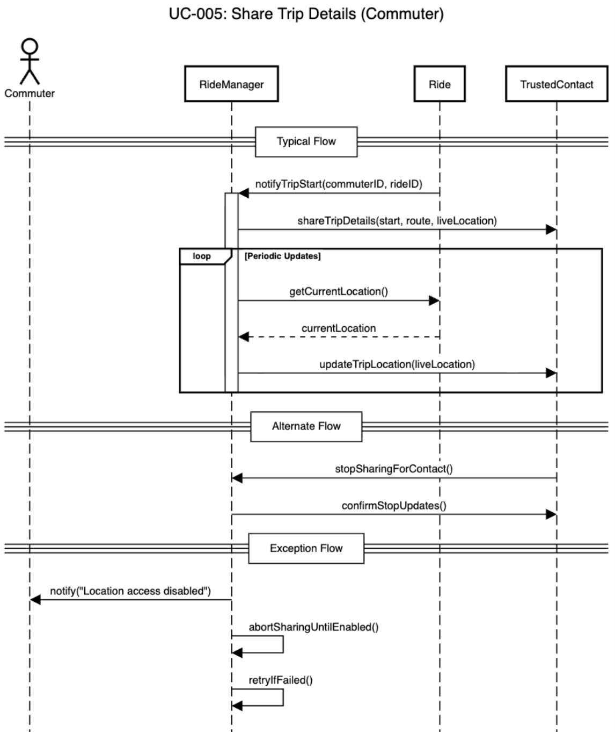

6. Make Payment (Commuter/Driver)

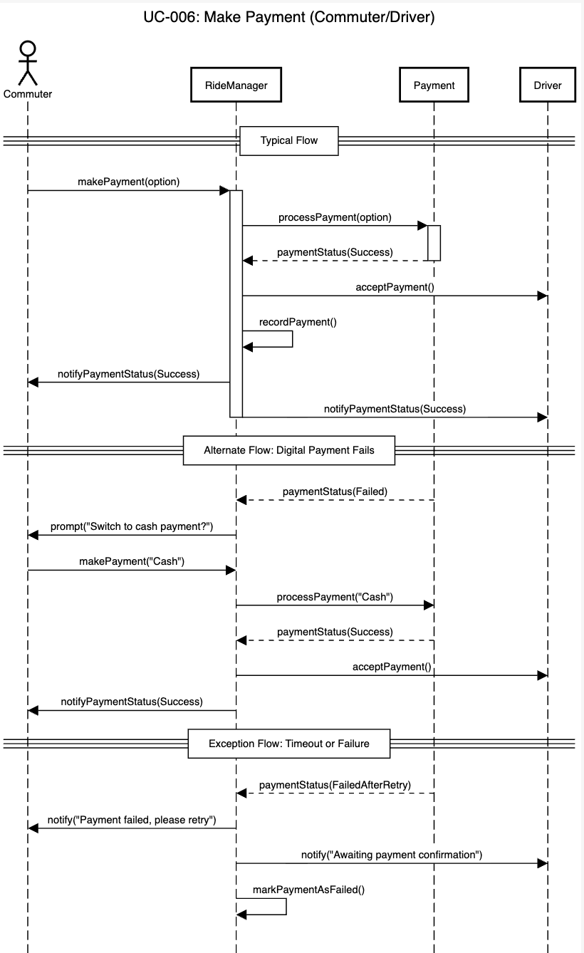

7. Rate Ride (Commuter)

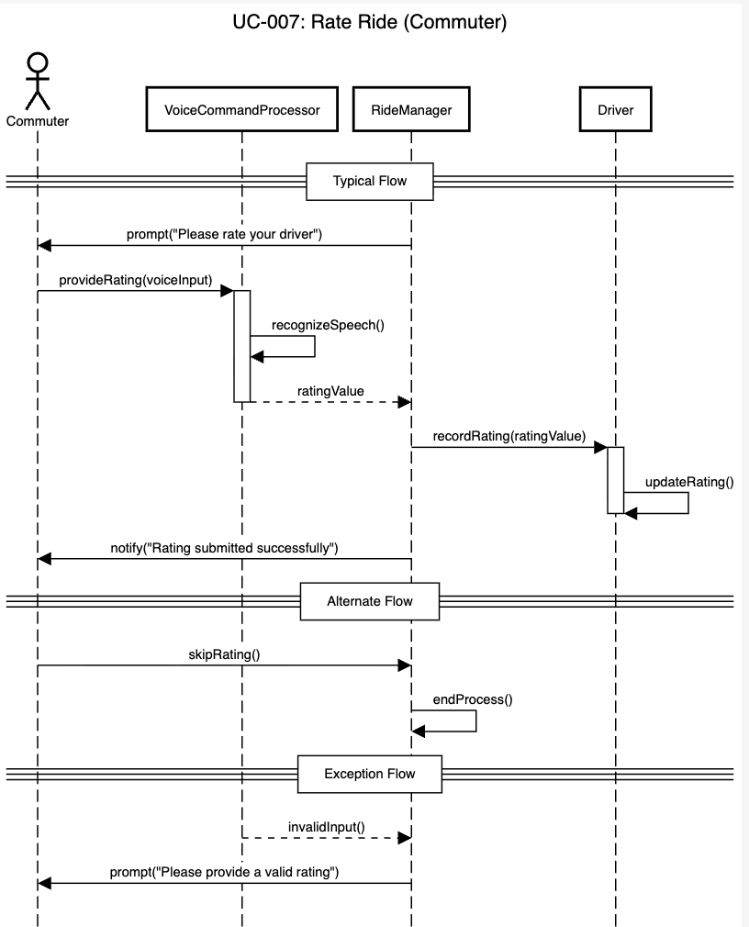

8. Verify User Identity

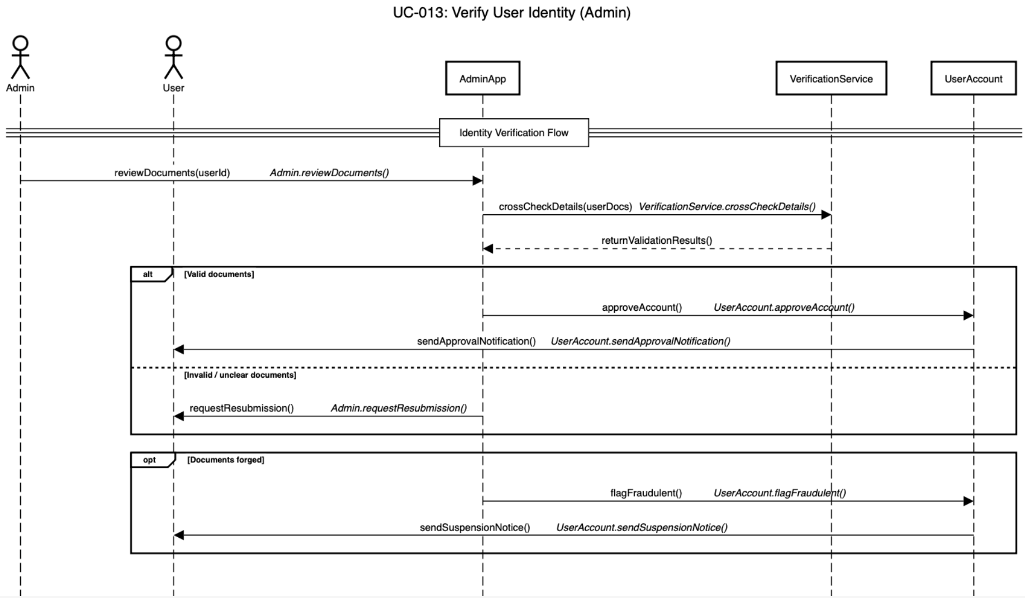

9. Send Safety Alerts (Admin)

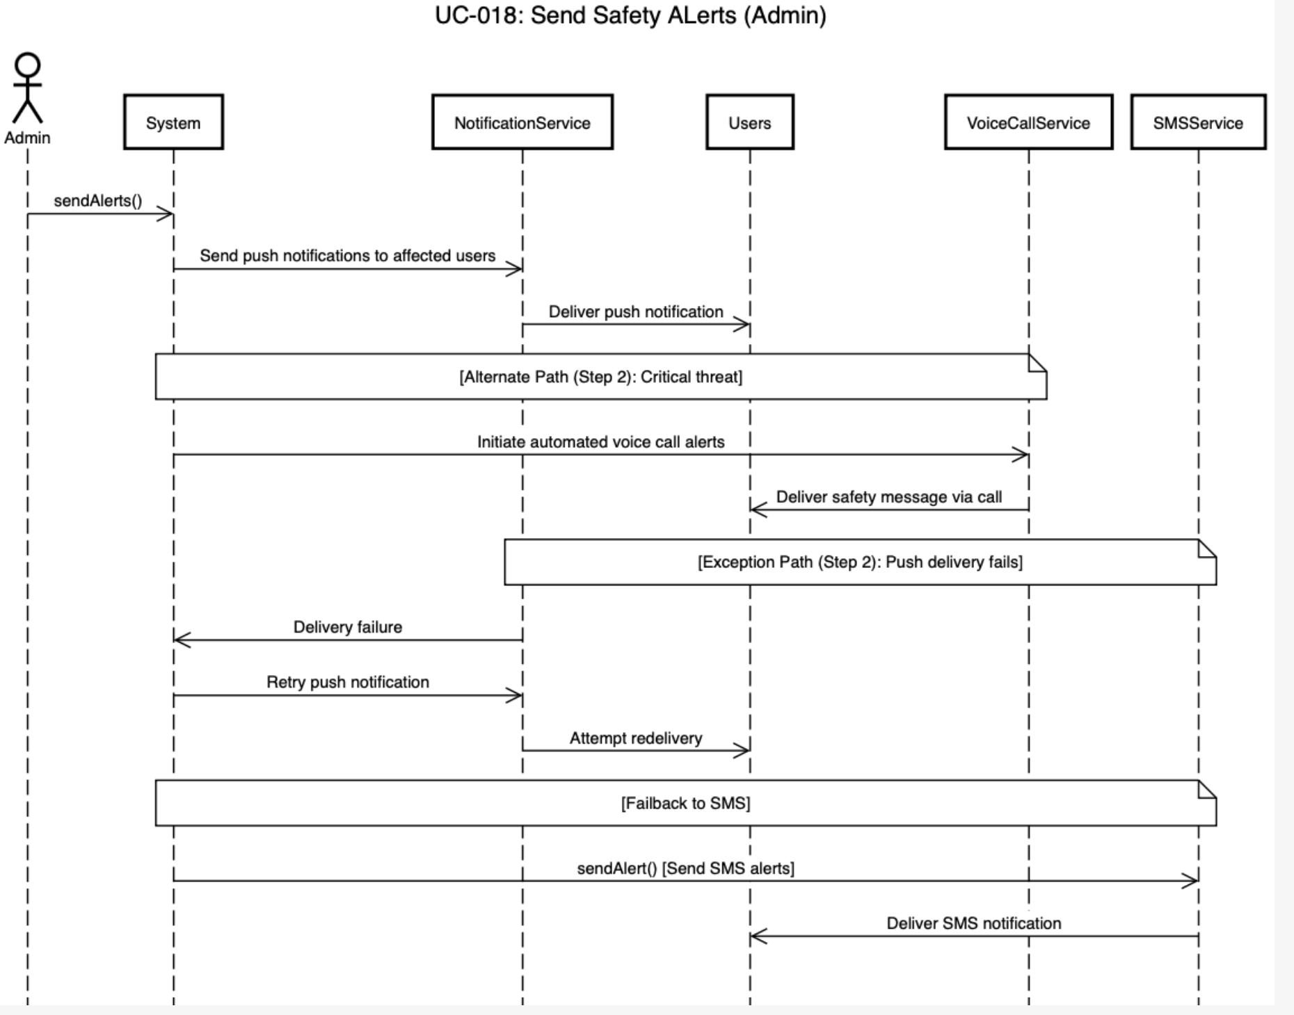

10. Update Fares & Policies

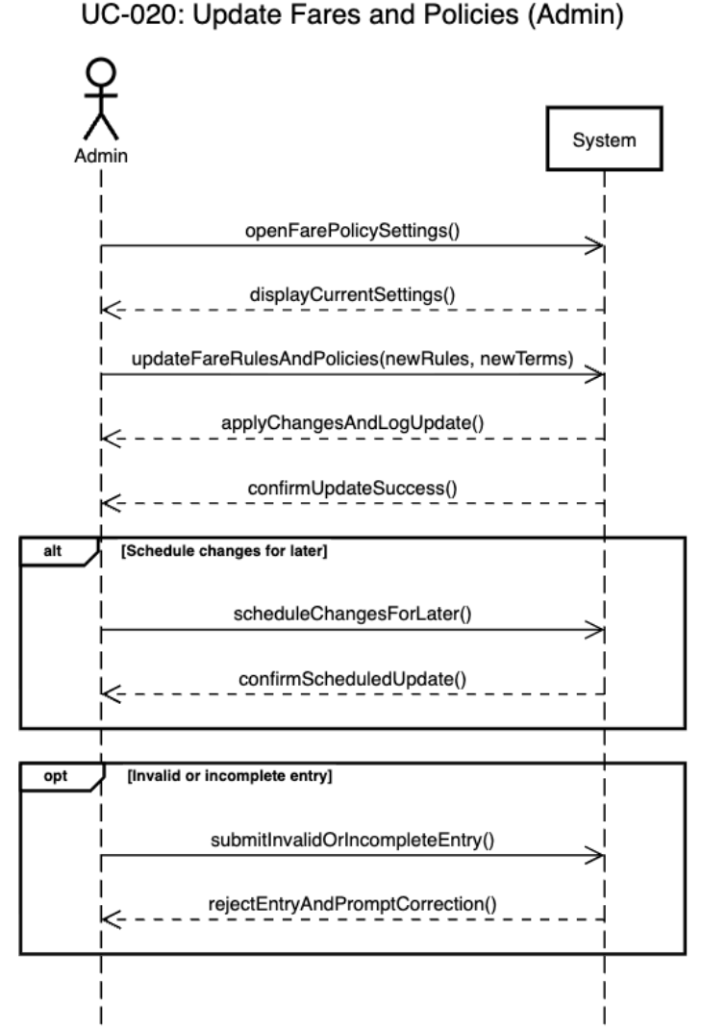

Software Development Methodology and Plan

This chapter describes the software development methodology adopted for building HerSafar and provides the justification for that choice. It begins by comparing two widely used development processes — Waterfall and Agile — outlining the strengths and weaknesses of each. It then explains why an Agile approach was selected for this project, given the nature of the application, the size of the team, and the evolving requirements that emerged throughout development.

Software Process Selection

Selecting the right software development process is an important early decision in any project. The process determines how work is planned, how requirements are handled, and how the team responds to change. Two of the most commonly discussed approaches are the Waterfall model and the Agile methodology. Each has its own strengths and limitations, and the right choice depends on the nature of the project.
Waterfall
The Waterfall model is a linear, sequential approach to software development. The project is divided into fixed phases — requirements, design, implementation, testing, and deployment — and each phase must be fully completed before the next one begins. There is no going back to an earlier phase once it has been signed off.
Pros:
• Simple and easy to understand. Each phase has a clear start and end point, which makes planning and progress tracking straightforward.
• Works well when requirements are well-defined and unlikely to change from the start.
• Produces thorough documentation at each stage, which can be useful for large teams or projects with strict compliance requirements.
Cons:
• Very inflexible. If requirements change midway through the project — which is common — the team has to go back to the beginning, which is costly and time-consuming.
• Testing only happens near the end of the development cycle, which means bugs and design flaws are often discovered late when they are harder and more expensive to fix.
• There is no working software to show until the very end, making it difficult to gather feedback or validate decisions during development.
Agile (including Scrum)
Agile is an iterative and incremental approach to software development. Work is broken down into short development cycles called sprints, typically lasting two to four weeks. At the end of each sprint, a working version of the software is produced and reviewed. Scrum is the most widely used framework within Agile, introducing defined roles such as Scrum Master and Product Owner, along with ceremonies like sprint planning, daily stand-ups, and retrospectives.
Pros:
• Highly flexible. Requirements can evolve between sprints without disrupting the entire project, allowing the team to respond to new information or feedback.
• Delivers working software incrementally, so progress is visible throughout the project rather than only at the end.
• Testing and integration happen continuously, which means issues are caught and resolved early.
• Encourages regular communication and collaboration within the team, which is especially useful for small teams working closely together.
Cons:
• The flexible nature of Agile can make it difficult to predict the final scope, timeline, or cost of a project upfront.
• Documentation is often less thorough compared to Waterfall, since the focus is on delivering working software quickly.
• Requires consistent involvement and communication from the team throughout the project. It can be harder to manage if team members are unavailable or working asynchronously.
Chosen Methodology: Agile
An Agile methodology was selected for the development of HerSafar. The primary reason for this choice is that the project requirements were not fully defined at the outset. HerSafar targets a user group — low-literacy female domestic workers — whose needs and constraints could not be fully anticipated in advance. Key design decisions, particularly around how the voice interface should behave and how the safety features should function, needed to be refined through testing and iteration rather than specified upfront.
A Waterfall approach would not have been appropriate here. Committing to a fixed set of requirements at the start would have made it very difficult to adjust the design as the team learned more about the problem. Any change in requirements mid-project would have required revisiting earlier phases, causing significant delays.
Agile allowed the team to divide the work into five focused sprints, each targeting a specific set of features. This made it possible to build, test, and refine one part of the system at a time, rather than attempting to deliver everything at once. Features that did not work as expected could be adjusted in the next sprint without affecting the rest of the project. This iterative approach was particularly valuable for the voice interaction and safety workflows, both of which went through multiple revisions before reaching their final form.
While a full Scrum framework was not adopted, the team did not use formal Scrum roles or ceremonies, the core principles of Agile were followed throughout: incremental delivery, continuous testing, and the flexibility to adapt based on what each sprint revealed. This approach suited the size and nature of the team and allowed HerSafar to be developed in a structured yet adaptable manner.

Database Design and Web Services
This chapter presents the data and web services design for HerSafar. It begins with the database design, describing the 10 MongoDB collections that form the system's data model — covering user and driver profiles, ride lifecycle records, payments, support tickets, safety alerts, unsafe areas, coupons, fare configurations, and platform policies. Each collection is described in detail with its fields and their purpose. The chapter concludes with the API specification, listing the external services integrated into the system, including Google Cloud APIs for speech, mapping, and translation, the Gemini AI API for voice intent processing, Resend for transactional email delivery, and Socket.IO for real-time communication.

6.1 Database Design

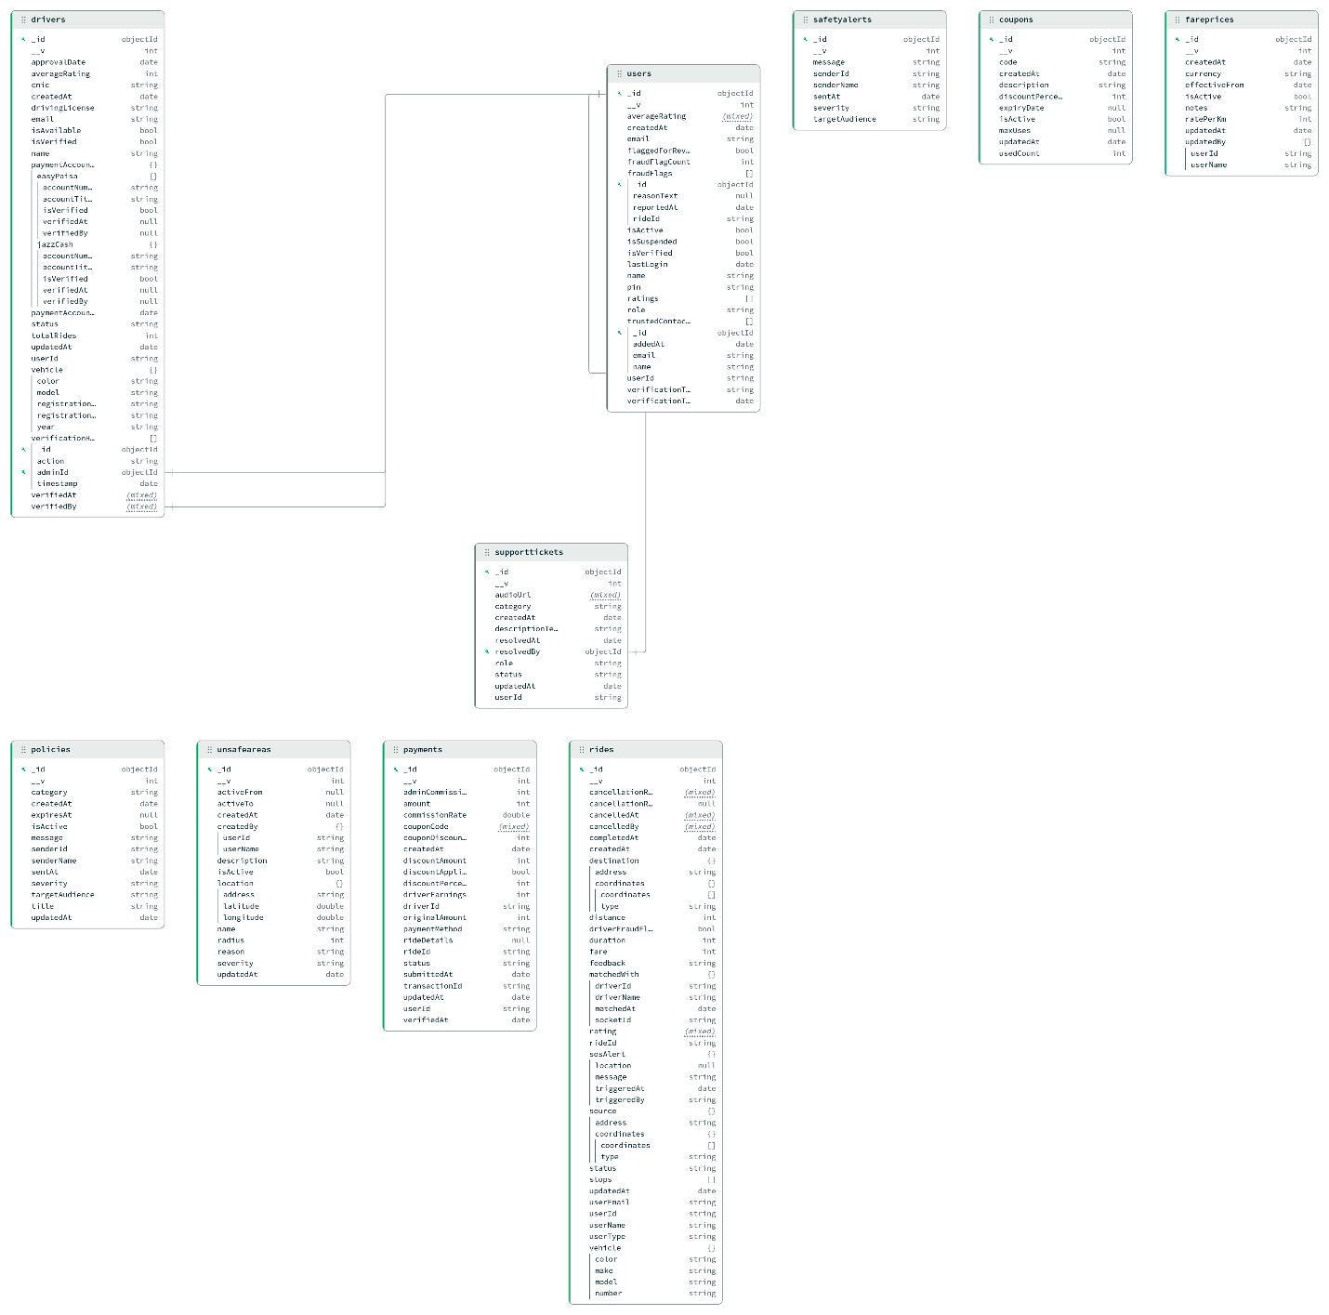

HerSafar uses MongoDB as its primary database. The data model consists of 10 collections, described in detail below.

Entity 1: users
Stores all registered accounts on the platform.

Field | Description
_id | Unique MongoDB document identifier (ObjectId)
name | Full name of the user
email | Unique email address used for login
pin | Optional numeric PIN for quick re-authentication
role | Role of the account — either commuter or admin
averageRating | Computed average of all ratings received from drivers
ratings | Array of individual rating entries given by drivers
isVerified | Whether the user's email has been verified
isSuspended | Whether the account has been suspended by an admin
flaggedForReview | Whether the account is under active admin review for suspicious activity
fraudFlagCount | Counter of how many fraud flags have been raised against this user
fraudFlags | Array of fraud flag records, each containing: rideId (the flagged ride), reasonText (reason for the flag), reportedAt (timestamp), and isActive (whether the flag is still open)
trustedContacts | Array of emergency contacts. Each entry stores the contact's name, email, userId, addedAt timestamp, and verificationToken / verificationTokenDate used to confirm the contact's consent
lastLogin | Timestamp of the user's most recent login
createdAt | Timestamp when the account was created
verifiedAt | Timestamp when email verification was completed
verifiedBy | Reference to the admin or system that performed verification

Entity 2: drivers
Stores profiles for registered drivers, including identity verification, vehicle details, and payment accounts.
Field | Description
_id | Unique MongoDB document identifier
userId | Reference to the corresponding users document (if driver also has a user account)
name | Full name of the driver
email | Driver's email address
cnic | National Identity Card number, used for identity verification
drivingLicense | URL of the uploaded driving licence image stored on Cloudinary
isVerified | Whether the driver's documents have been approved by an admin
isAvailable | Whether the driver is currently online and accepting ride requests
status | Current account status (e.g., pending, active, suspended)
approvalDate | Date when the driver's account was approved by an admin
averageRating | Computed average of all ratings received from commuters
totalRides | Cumulative count of rides completed by this driver
vehicle | Embedded object containing the driver's vehicle details: color, model, year, and registrationNumber
paymentAccounts.easyPaisa | EasyPaisa mobile wallet details: accountNum, accountTitle, isVerified, verifiedAt, verifiedBy
paymentAccounts.jazzCash | JazzCash mobile wallet details: same sub-fields as EasyPaisa
paymentAccountUpdatedAt | Timestamp of the last update to payment account information
verificationNotes | Free-text notes added by an admin during the document review process
verificationLog | Array of audit entries tracking each admin action on this driver's account, each containing action, adminId, and timestamp
verifiedAt | Timestamp when the driver was fully verified
verifiedBy | Admin ID who approved the driver
updatedAt | Timestamp of the last update to the driver document

Entity 3: rides
Records every ride request, its lifecycle, matched driver, fare, and safety data.

Field | Description
_id | Unique MongoDB document identifier
rideId | Human-readable or secondary ride identifier
userId | Reference to the commuter who booked the ride
userName | Snapshot of the commuter's name at the time of booking
userEmail | Snapshot of the commuter's email at the time of booking
userType | Role of the booking user (commuter)
source | Pickup location object containing address (text), type, and coordinates (lat/lng array)
destination | Drop-off location object with the same structure as source
stops | Array of intermediate stops between source and destination
distance | Total ride distance in kilometres
duration | Total ride duration in minutes
fare | Final calculated fare for the ride
status | Current state of the ride (e.g., requested, accepted, in_progress, completed, cancelled)
matchedWith | Embedded object for the assigned driver: driverId, driverName, matchedAt timestamp, and socketId for real-time communication
vehicle | Snapshot of the driver's vehicle at the time of the ride: color, make, model, number
rating | Rating given by the commuter after ride completion
feedback | Free-text feedback provided by the commuter
sosAlert | Embedded SOS record if triggered during the ride: location, message, triggeredAt, triggeredBy
driverFraudFlag | Boolean indicating whether the driver was flagged for suspicious behaviour on this ride
cancellationReason | Reason code for cancellation (if applicable)
cancellationReasonText | Free-text explanation of the cancellation
cancelledAt | Timestamp when the ride was cancelled
cancelledBy | Reference to the user (commuter or driver) who cancelled
completedAt | Timestamp when the ride was completed
createdAt | Timestamp when the ride request was created
updatedAt | Timestamp of the last status update

Entity 4: payments
Records financial transactions associated with each completed ride.
Field | Description
_id | Unique MongoDB document identifier
rideId | Reference to the associated ride
userId | Reference to the commuter who made the payment
driverId | Reference to the driver who received earnings
paymentMethod | Payment method selected by the commuter — easypaisa, jazzcash, or cash
originalAmount | Ride fare before any discounts
discountApplied | Boolean indicating whether a coupon was applied
couponCode | The coupon code used, if any
couponDiscount | Discount amount deducted via coupon
discountPercentage | Percentage of the discount applied
discountAmount | Absolute monetary value of the discount
amount | Final amount charged to the commuter after discounts
commissionRate | Platform commission percentage charged on the fare
adminCommission | Absolute monetary value of the platform's commission
driverEarnings | Amount credited to the driver after commission deduction
status | Payment status (e.g., pending, completed, failed)
transactionId | External transaction reference from EasyPaisa/JazzCash gateway
rideDetails | Snapshot of key ride details at payment time
submittedDate | Date the payment was submitted
verifiedAt | Date the payment was verified by the system or admin
updatedAt | Timestamp of the last update to the payment record

Entity 5: supporttickets
Tracks customer support requests submitted by commuters or drivers.
Field | Description
_id | Unique MongoDB document identifier
userId | Reference to the user who submitted the ticket
role | Role of the submitter — commuter or driver
category | Category of the issue (e.g., payment dispute, safety concern, account issue)
descriptionText | Detailed description of the issue written by the user
audioUrl | Optional URL of a voice recording attached to the ticket
status | Current status of the ticket (e.g., open, in_progress, resolved)
resolvedBy | Reference to the admin who resolved the ticket
resolvedAt | Timestamp when the ticket was resolved
createdAt | Timestamp when the ticket was submitted
updatedAt | Timestamp of the last update

Entity 6: safetyalerts
Stores platform-wide safety broadcasts sent by admins to commuters and/or drivers.
Field | Description
_id | Unique MongoDB document identifier
message | Content of the safety alert message
senderId | Reference to the admin who created the alert
senderName | Name of the admin who sent the alert
sentAt | Timestamp when the alert was broadcast
severity | Severity level of the alert (e.g., low, medium, high)
targetAudience | Who the alert is directed at — commuters, drivers, or all

Entity 7: unsafeareas
Records geographic areas flagged as unsafe by admins, used to warn commuters during route planning.

Field | Description
_id | Unique MongoDB document identifier
name | Human-readable name for the unsafe area
description | Explanation of why the area is flagged
reason | Short reason code or tag for the flag
severity | Risk severity level of the area
location | Embedded location object: address (text), latitude, longitude, radius (in metres defining the flagged zone)
isActive | Whether the unsafe area flag is currently active
activeFrom | Date from which the area is considered unsafe
activeTo | Date until which the area is considered unsafe (null if indefinite)
createdBy | Embedded object with userId and userName of the admin who flagged the area
createdAt | Timestamp when the record was created
updatedAt | Timestamp of the last update

Entity 8: coupons
Stores promotional discount codes that commuters can apply to reduce their ride fare.
Field | Description
_id | Unique MongoDB document identifier
code | Unique alphanumeric coupon code entered by the user
description | Human-readable description of the offer
discountPercentage | Percentage discount applied to the ride fare
expiryDate | Date after which the coupon is no longer valid
isActive | Whether the coupon is currently available for use
maxUses | Maximum number of times the coupon can be redeemed across all users
usedCount | Running count of how many times the coupon has been redeemed
createdAt | Timestamp when the coupon was created
updatedAt | Timestamp of the last modification

Entity 9: fareprices
Stores the active fare configuration used to calculate ride costs.
Field | Description
_id | Unique MongoDB document identifier
ratePerKm | Price charged per kilometre of distance travelled
currency | Currency code for the fare (e.g., PKR)
effectiveFrom | Date from which this fare configuration is valid
isActive | Whether this fare configuration is currently in use
notes | Optional admin notes explaining the reason for the fare update
updatedBy | Embedded object with userId and userName of the admin who set the fare
createdAt | Timestamp when the fare record was created
updatedAt | Timestamp of the last modification

Entity 10: policies
Stores platform policies and announcements published by admins (e.g., terms updates, conduct rules).

Field | Description
_id | Unique MongoDB document identifier
title | Title of the policy or announcement
category | Category of the policy (e.g., safety, payment, conduct)
message | Full body text of the policy
severity | Importance level of the policy
targetAudience | Who the policy applies to — commuters, drivers, or all
isActive | Whether the policy is currently in effect
senderId | Reference to the admin who published the policy
senderName | Name of the publishing admin
sentAt | Timestamp when the policy was published
expiresAt | Date when the policy expires (null if permanent)
createdAt | Timestamp when the record was created
updatedAt | Timestamp of the last modification

6.2 API Specification
This sub-section will contain the list of external APIs that you have used in your project.
Service | Provider | Purpose
Text-to-Speech API | Google Cloud | Urdu speech synthesis for voice UI
Gemini AI API | Google AI | Intent classification, email/name extraction from speech
Geocoding API | Google Cloud | Address ↔ coordinates conversion
Directions API | Google Cloud | Route calculation between pickup and destination
Distance Matrix API | Google Cloud | Distance and ETA calculation for fare
Static Maps API | Google Cloud | Map image generation for ride summary emails
Translation API | Google Cloud | Address translation between English and Urdu
Maps Flutter SDK | Google | Interactive maps and live driver tracking
Resend Email API | Resend | All transactional email delivery
Socket.IO | Socket.IO | Real-time location, chat, and event delivery

System User Interface
- Commuter Interface
  - Commuter Home Screen
- The commuter can click the “رائڈ بک کریں” button to book a ride. The system continuously provides voice prompts to guide the user through the booking process.


1.2. Book a Ride Page
- The commuter can tap the microphone icon and specify the destination using voice input.
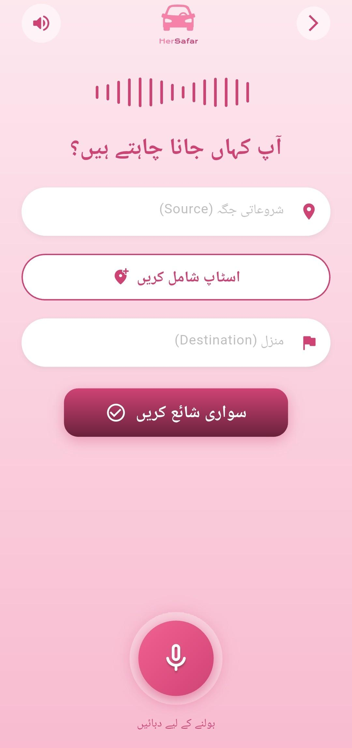

1.3. Share Trip Details
- To enhance user safety, the system allows the commuter to share ride details with trusted contacts in real time.
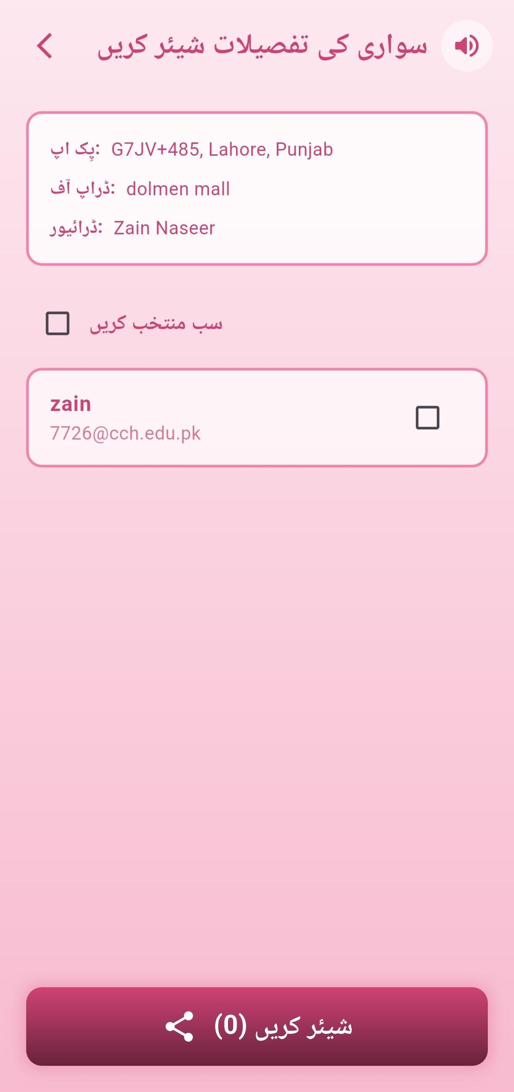

1.4. SOS Alert
- The Active Ride page features an SOS button that enables the commuter to instantly send an emergency notification to their trusted contacts in case of danger.

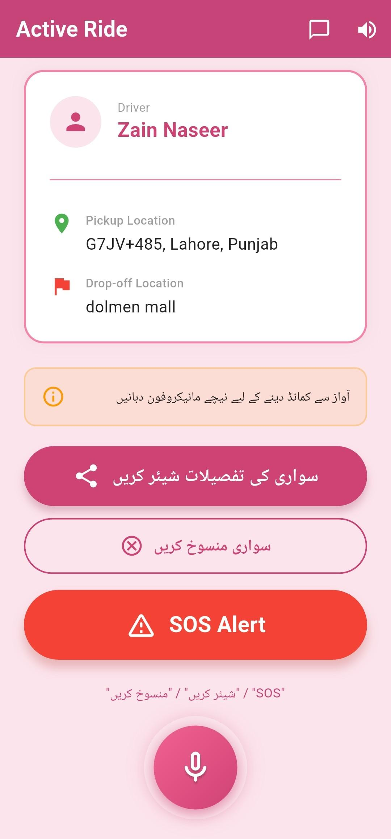

1.5. Payment Page
- Users can select from multiple payment methods, including Cash, JazzCash, and EasyPaisa. The system features integrated voice guidance to assist users throughout the process. Clicking the "Confirm Payment" button finalizes the transaction.
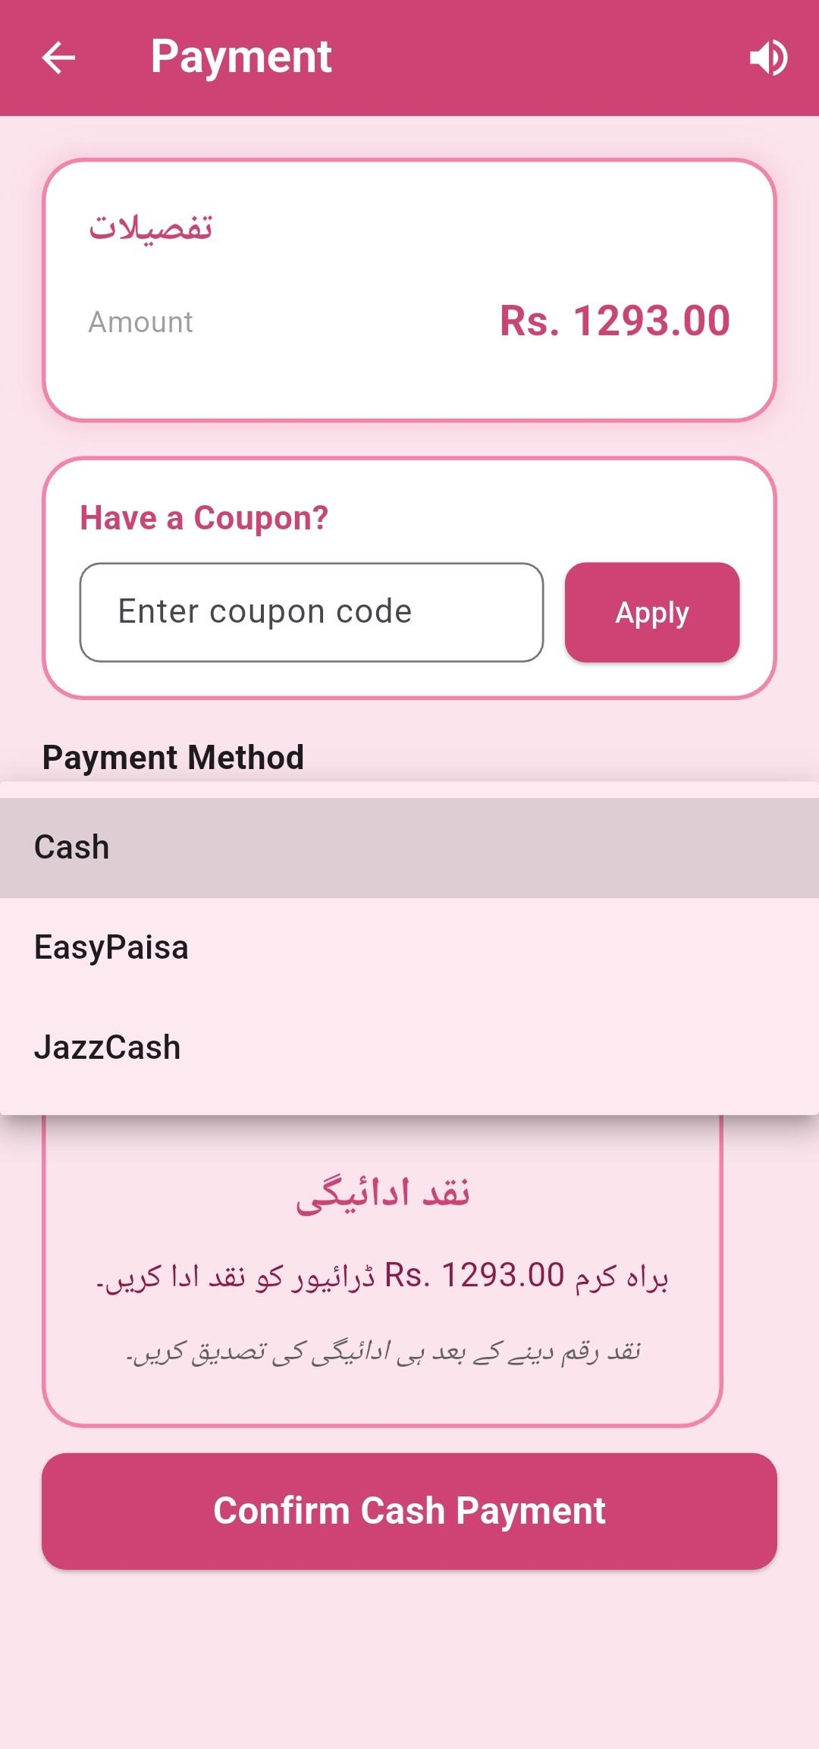

1.6. Give a Rating
- After completing the payment, the commuter is redirected to the Home Screen, where a rating modal appears. This allows the user to rate their ride experience.
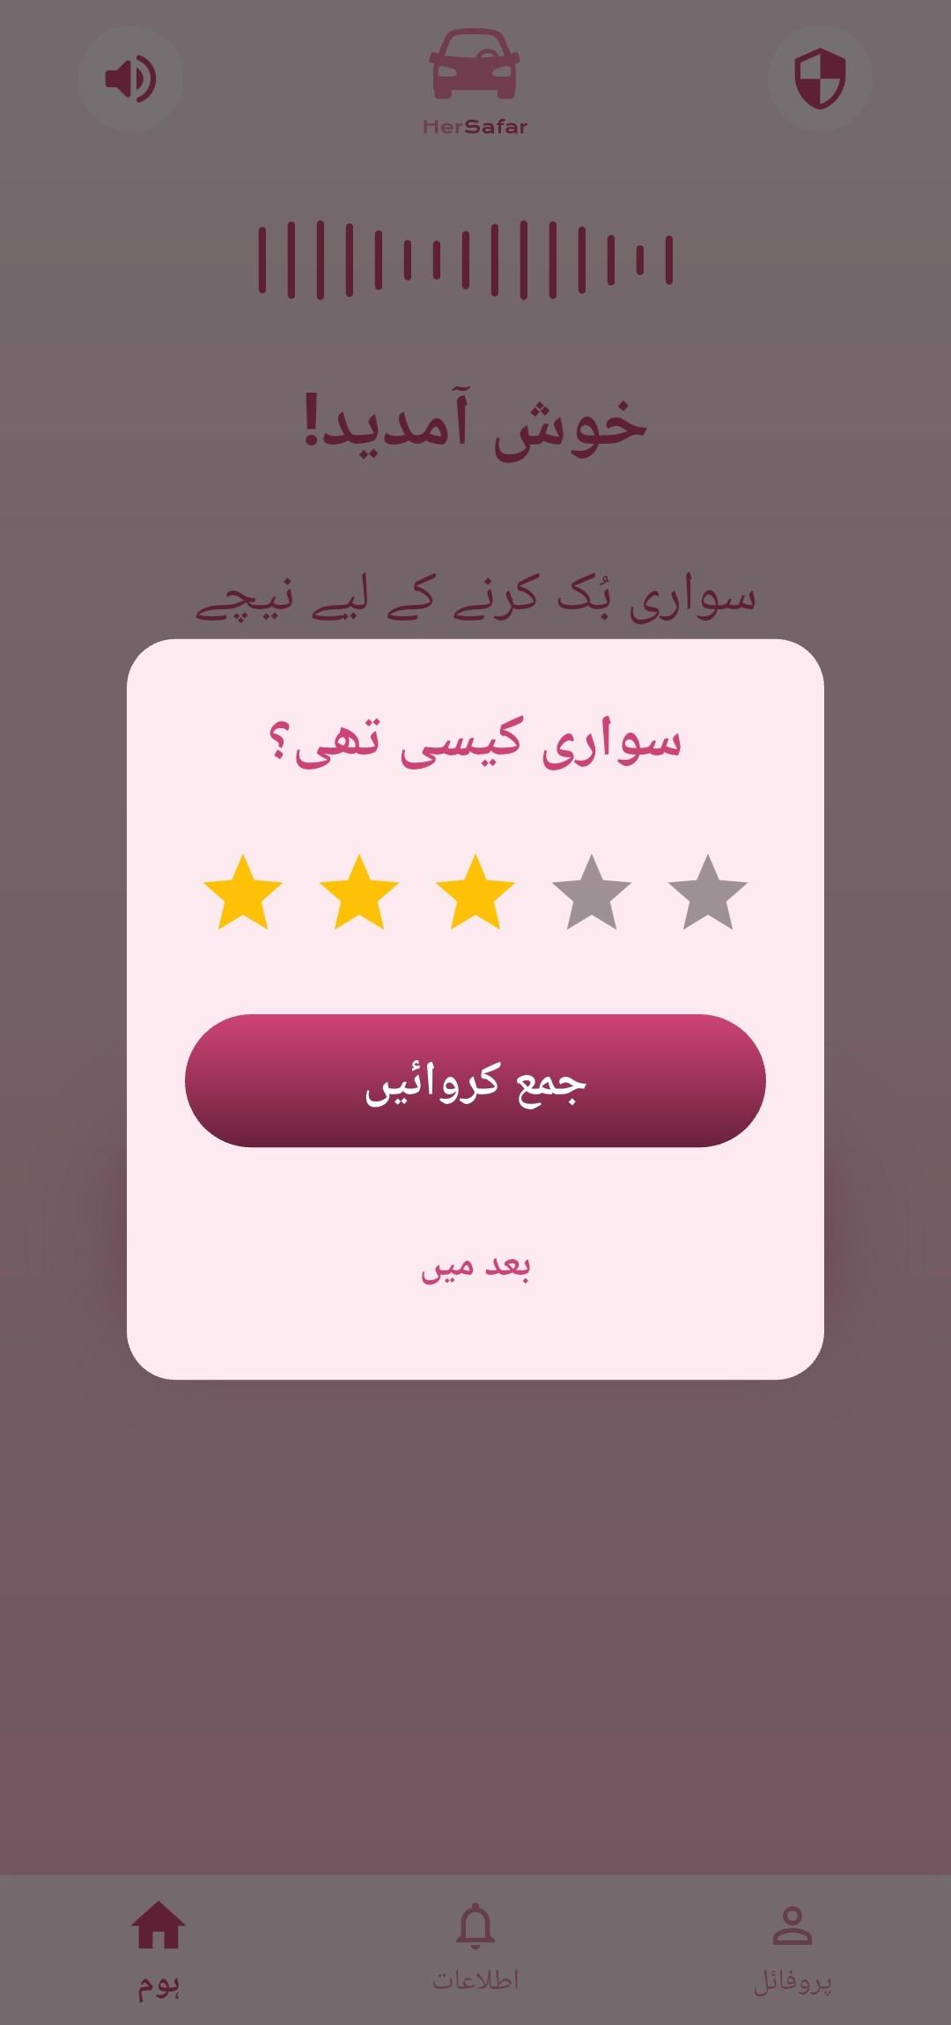

2. Admin Interface
- Send Safety Alerts
- The Admin can broadcast safety alerts to all drivers and commuters. Each alert includes a severity level (e.g., Low, Medium, High, Critical) to define the urgency of the broadcast.

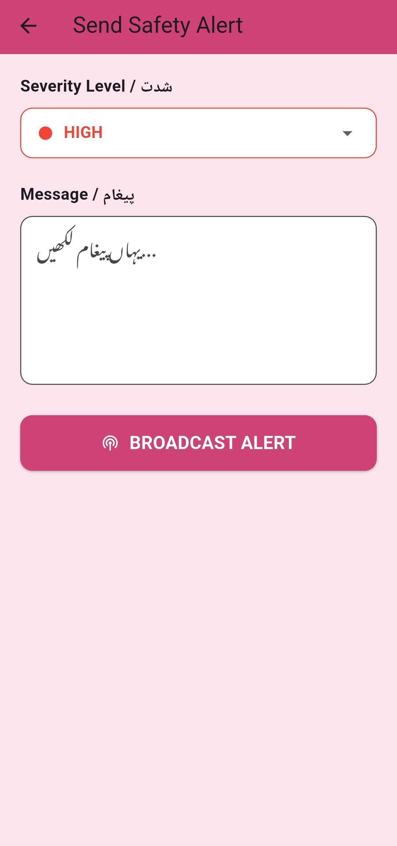

2. Broadcast Policy Update
The Admin can broadcast organizational policies to specific target audiences. Unlike safety alerts, this feature allows the Admin to filter recipients, targeting commuters, drivers, or both.

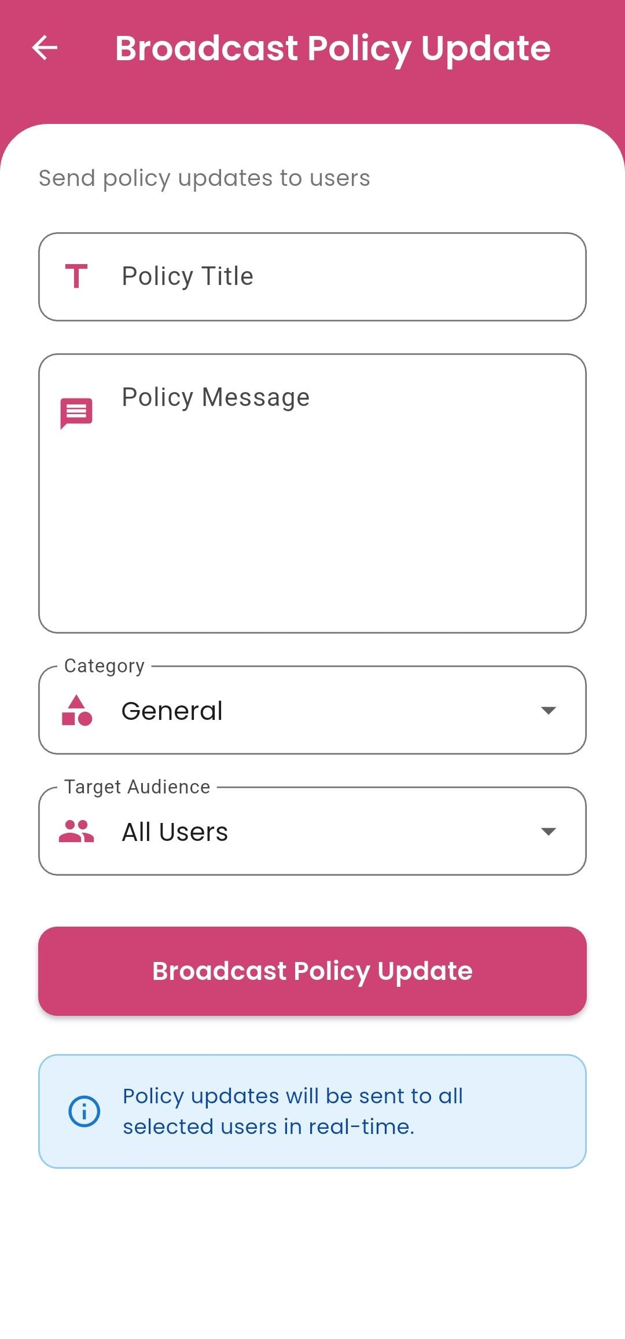

3. Driver Interface
- Reached Commuter Destination
- Upon arriving at the destination, the driver triggers the "I Have Reached" action to notify the commuter. Additionally, an in-app chat feature is accessible via the top-right corner, enabling real-time communication between the driver and the commuter.

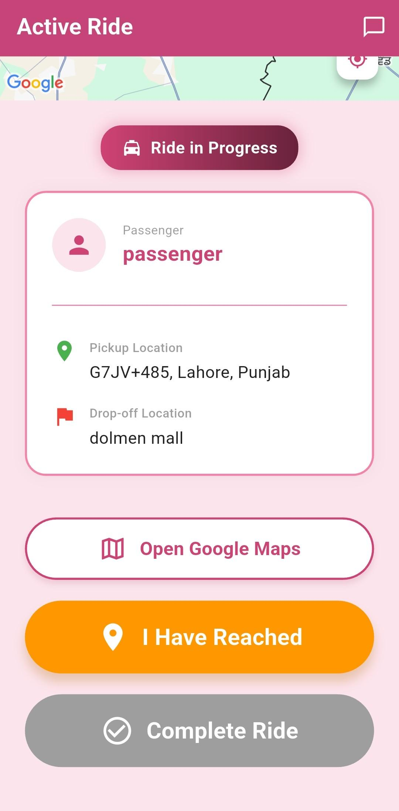

- Complete Ride
- The driver interface includes a "Complete Ride" button. Once triggered, the system automatically prompts a payment modal on the commuter’s screen to initiate the transaction.

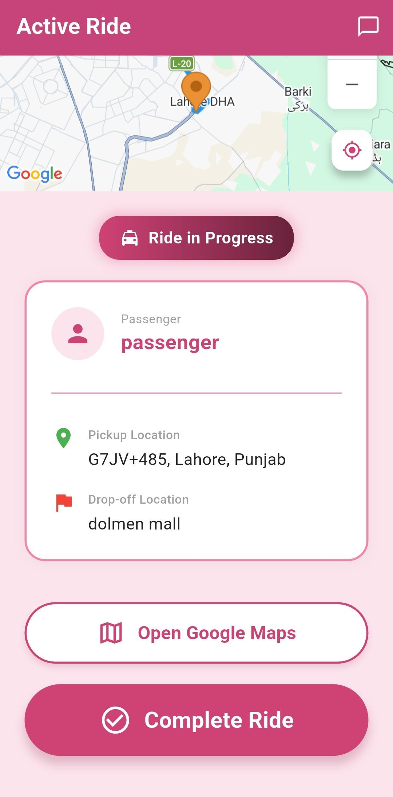

Project Security
HerSafar's security analysis was conducted using the STRIDE framework, applied across all major use cases throughout the development sprints
STRIDE Threat Analysis
All use cases were systematically analyzed against the six STRIDE threat categories. Key findings and controls are summarized below:
- Spoofing — All user roles (Commuter, Driver, Admin, Trusted Contact) are authenticated via JWT tokens with expiration and refresh rotation. Admin actions additionally require MFA. Driver identity is verified through CNIC and license document checks before account approval (UC-013).
- Tampering — HTTPS/TLS is enforced across all communications. Server-side validation is applied on every input. Driver resubmission documents are integrity-checked using SHA-256 hashing. Live GPS payloads for real-time ride tracking (UC-016) are signed and validated server-side to prevent spoofed location data.
- Repudiation — Immutable audit logs are maintained for all critical actions including admin verifications, payment processing, SOS triggers (UC-004), and support ticket resolutions. Each log entry captures user ID, timestamp, IP address, and action detail.
- Information Disclosure — Role-based access control (RBAC) is enforced on all endpoints via authorize() middleware. Sensitive fields such as CNIC numbers and internal file paths are never returned in API responses. Generic error messages are used in production to prevent system detail leakage.
- Denial of Service — Rate limiting is applied on high-risk endpoints including login, SOS dispatch, file upload, and analytics export. Pagination is enforced on all data-heavy queries. File uploads are capped at 5MB with a one-file-per-request limit.
- Elevation of Privilege — A strict role hierarchy (Commuter → Driver → Admin) is enforced server-side on every request. Protected fields such as verification status, driver ratings, and admin roles are marked read-only at the schema level and cannot be modified through any user-facing endpoint.
OWASP Top 10 Alignment
The STRIDE analysis was cross-referenced with the OWASP Top 10 to ensure comprehensive coverage:
STRIDE Category | OWASP Mapping
Spoofing & Elevation of Privilege | A01 – Broken Access Control
Information Disclosure | A02 – Cryptographic Failures
Tampering | A03 – Injection (mitigated via input sanitization and Mongoose parameterized queries)
Repudiation | A09 – Security Logging & Monitoring Failures (addressed through audit logging)
Denial of Service | A10 – Server-Side Request Forgery (SSRF)

Static Code Analysis — SonarQube
SonarQube was integrated into the development pipeline for automated static analysis. It was used to identify security hotspots, code smells, and potential vulnerabilities across the codebase, complementing the manual STRIDE analysis. Issues flagged were reviewed and resolved iteratively across sprints.

Risk Management

Potential Risks and Mitigation Strategies

Sr. | Risk Description | Mitigation Strategy
 | Voice recognition may misinterpret user commands due to accents or background noise. | Provide manual input fallback, confirmation prompts, etc.
 | The application may not support all local languages or accents, causing difficulty for users in understanding or using voice commands. | Integrate multi-language support (e.g., Urdu/English), allow language selection in settings, and provide a manual input option as a fallback.
 | Poor internet connectivity may disrupt booking and real-time updates. | Implement offline support for basic features and optimize API calls for low bandwidth.
 | User data (location, voice data) may be vulnerable to security breaches. | Use encryption (HTTPS), secure authentication (JWT), and proper access control.
 | Delay in voice processing may degrade user experience. | Use efficient voice processing APIs and implement asynchronous handling with feedback indicators.
 | Lack of available drivers in certain areas may result in failed bookings. | Expand search radius dynamically and show estimated wait times.
 | Background noise or unintended speech may trigger incorrect actions. | Implement wake-word detection and confirmation before final actions.
 | Users may find the voice-based system difficult to use initially. | Provide onboarding tutorials and maintain a simple UI with guided prompts.
 | System may fail under high user load (scalability issues). | Deploy scalable infratstructure that automatically scales in/out during peak and non peak times and use load balancing techniques.
 | GPS inaccuracies may lead to incorrect pickup or drop locations. | Enable manual location selection and use high-accuracy GPS with validation checks.

Testing and Evaluation

Testing Strategy
HerSafar was tested using a combination of unit testing, integration testing, and manual end-to-end (E2E) testing.
- Unit Testing: Individual controller functions and utility methods were tested in isolation using Jest. A separate MONGO_URI_TEST environment variable points to a dedicated test database to avoid polluting production data.
- Integration Testing: API endpoints were tested using Postman collections, verifying request/response contracts for all major routes (auth, rides, voice, admin).
- Manual E2E Testing: Core user journeys (register → book ride → pay → complete) were manually tested on Android devices and the Flutter web build.
- AI Test Cases: Voice endpoint responses were tested with Urdu audio samples — including edge cases such as accented pronunciation, background noise, and phonetic email spelling — to validate Gemini's extraction accuracy.

Sample Test Cases

# | Test Case | Input | Expected Output | Result
TC1 | User registration with valid data | Name, email, password | 201 Created + JWT | Pass
TC2 | Login with wrong password | Correct email, wrong password | 401 Unauthorized | Pass
TC3 | Access protected route without JWT | No Authorization header | 403 Forbidden | Pass
TC4 | STT endpoint with Urdu WAV file | 16kHz mono WAV | Transcribed Urdu text | Pass
TC5 | Gemini intent classification — new user | "نیا اکاؤنٹ بنانا ہے" | Returns 0 (new user) | Pass
TC6 | Gemini email extraction | Urdu phonetic spelling of email | Correct email string | Pass
TC7 | Book ride with missing dropoff | pickup only | 400 Bad Request | Pass
TC8 | Admin broadcasts safety alert | Title, severity, area | Alert stored + pushed to users | Pass
TC9 | Driver uploads CNIC image | JPEG image file | OCR result + pending verification | Pass
TC10 | SOS trigger during active ride | Tap SOS button | Alert created + admin notified | Pass

Automation Tools
- Jest — backend unit and integration test runner
- Postman — API contract testing and collection runner
- SonarCloud — automated static analysis on every CI run (GitHub Actions)
- GitHub Actions — CI pipeline runs tests and quality gates before deployment

Deployment Guidelines

11.1 Source Code
Backend repository | https://github.com/Muhammad-Zain-Naseer/FYP-Backend
Frontend repository | https://github.com/Muhammad-Zain-Naseer/FYP-Frontend-Flutter

11.2 Prerequisites
Before deploying, ensure the following are available:
- An Oracle Cloud Infrastructure (OCI) account with an active OKE cluster
- A GitHub account with access to both repositories
- A GitHub Container Registry (GHCR) Personal Access Token with read:packages and write:packages scopes
- A MongoDB Atlas cluster with two databases: one for production and one for testing

11.3 Step 1 — Set GitHub Secrets
Go to each repository: Settings → Secrets and variables → Actions → New repository secret. Add the following secrets:
Application secrets (injected into Kubernetes pods at deploy time):
Secret Name | Purpose
MONGODB_URI | MongoDB production connection string
MONGO_URI_TEST | MongoDB test database connection string
JWT_SECRET | Secret key used for signing and verifying JWT tokens
ENCRYPTION_KEY | Key used for encrypting sensitive fields in the database
GOOGLE_TTS_API_KEY | Google Cloud Text-to-Speech API key
GOOGLE_STT_API_KEY | Google Cloud Speech-to-Text API key
GOOGLE_MAPS_API_KEY | Google Maps, Geocoding, Directions, Distance Matrix, and Translation API key
RESEND_API_KEY | Resend transactional email service API key
GEMINI_API_KEY_1 through GEMINI_API_KEY_13 | 13 Gemini AI API keys used in round-robin rotation to stay within free-tier rate limits (10 RPM / 500 RPD per key)

Infrastructure secrets (used by the CD pipeline to connect to Oracle Cloud):
Secret Name | Purpose
OCI_PRIVATE_KEY | OCI API private key for authenticating with Oracle Cloud
OCI_USER_OCID | Oracle Cloud user OCID
OCI_FINGERPRINT | Fingerprint of the OCI API signing key
OCI_TENANCY_OCID | Oracle Cloud tenancy OCID
OCI_REGION | OCI region identifier (e.g., ap-mumbai-1)
OKE_CLUSTER_OCID | OCID of the target Oracle Kubernetes Engine cluster
GHCR_USERNAME | GitHub username for authenticating with the container registry
GHCR_PAT | GitHub Personal Access Token with read:packages scope for pulling the Docker image

11.4 Step 2 — Configure Local Environment (Development Only)
- Clone the backend repository and create a .env file based on the provided .env.example:
- git clone https://github.com/Muhammad-Zain-Naseer/FYP-Backend.git
- cd FYP-Backend
- cp .env.example .env
- # Fill in all values in .env
- npm install
- npm run dev
The server starts on PORT=3000 by default (NODE_ENV=development).

11.5 Step 3 — Deploy to Production (Automated via CI/CD)
Push or merge to the main branch. The GitHub Actions pipeline triggers automatically in two stages:

11.5.1 Stage 1 — CI (ci.yml):
- Installs dependencies (npm ci)
- Runs linting and unit tests against MONGO_URI_TEST
- Runs SonarCloud static analysis and security scan
- Builds the Docker image and pushes it to GitHub Container Registry (GHCR) tagged with the commit SHA

11.5.2 Stage 2 — CD (cd.yml) (runs only if CI passes):
- Installs the OCI CLI and configures credentials using the OCI infrastructure secrets
- Generates a kubeconfig for the OKE cluster
- Creates the hersafar-app Kubernetes namespace if it does not exist
- Creates the GHCR image pull secret so OKE can pull the Docker image
- Deletes and recreates the backend-secrets Kubernetes secret with all updated application secrets
- Applies k8s/backend-deployment.yaml — updates the running deployment with the new image tag
- Waits for the rollout to complete successfully (kubectl rollout status)
- Applies k8s/backend-service.yaml and k8s/ingress.yaml to expose the service
No manual steps are required after merging to main.

11.6 Step 4 — Verify Deployment
After the pipeline completes, verify the deployment using the following commands:
- kubectl get pods -n hersafar-app (# Check all pods are Running)
- kubectl logs <pod-name> -n hersafar-app (# View application logs)
- kubectl get ingress -n hersafar-app (# Check the public service endpoint)
11.7 Step 5 — Flutter Frontend Deployment
- git clone https://github.com/Muhammad-Zain-Naseer/FYP-Frontend-Flutter.git
- cd FYP-Frontend-Flutter
- Update the backend base URL in lib/utils/api_client.dart
- to point to the production OKE ingress IP / domain
- flutter build apk –release (# Build for Android)
- flutter build web (# Build for Web)
The production backend is accessible at the domain configured in k8s/ingress.yaml.
kubectl rollout undo deployment/backend -n hersafar-app

Conclusion

12.1 Summary
This project was approached as a full-stack, user-centered system design problem focused on building a safe and accessible ride-hailing application for female domestic workers in Pakistan. The development process followed an iterative methodology across multiple sprints, starting from requirements analysis and system design to implementation, testing, and integration of core features such as real-time tracking, authentication, and voice-based interaction.
Throughout the project, we worked on both technical and design aspects of the system, including backend development using Node.js and Express, mobile app development in Flutter, and integration of real-time communication using Socket.IO. We also explored security considerations through structured threat modeling and applied the STRIDE framework to identify and mitigate potential risks.
Beyond technical implementation, a key learning outcome was understanding the importance of designing for accessibility and inclusivity. Building for users with low literacy and limited digital experience required rethinking traditional interface assumptions and prioritizing simplicity, voice interaction, and clarity over feature complexity.

12.2 Challenges
Elaborate the issues and challenges, both technical and non-technical, faced during this project and how you have addressed them.
The project involved several technical and non-technical challenges. On the technical side, one major issue was managing reliance on external APIs for maps, location tracking, and speech processing. High API usage during development created cost and rate-limit constraints, which were addressed by introducing caching mechanisms and optimizing request handling.
Another significant challenge was implementing reliable speech recognition for Urdu. Initial Flutter-based speech packages were inconsistent and failed in certain environments. This was resolved by integrating the Gemini API for speech-to-text and Google Cloud Text-to-Speech for audio output, which provided more stable and accurate performance.
Real-time location tracking and synchronization also required careful handling to ensure consistency between driver and commuter views. On the non-technical side, coordinating development across multiple team members introduced challenges in integration and version control, which were managed through structured sprint planning, task allocation, and regular code reviews.

12.3 Future
Describe how the application can be extended in the future by you or someone else. Include any recommendations that you received from visitors on project showcase day.
HerSafar can be extended in multiple directions to improve scalability, intelligence, and accessibility.
First, the system can be expanded to support additional regional languages such as Punjabi, Sindhi, and other local dialects, enabling wider adoption beyond Urdu-speaking users.
Computer vision and OCR can be introduced to automatically extract information from identity documents such as CNICs and driver licenses, reducing manual data entry and simplifying the onboarding process.
The safety system can also be further enhanced by leveraging richer datasets and historical trip data to improve unsafe area detection, allowing more adaptive and context-aware route recommendations.
An offline-first approach can be introduced in future versions to ensure that critical features such as SOS alerts and basic ride information remain functional even in low or no connectivity environments.
Urdu speech recognition can be improved to better handle regional accents and noisy commuting conditions, increasing reliability in real-world usage.
Feedback from the project showcase highlighted the need for a web-based administrative dashboard with analytics, ride monitoring tools, and unsafe area visualizations, which would strengthen system oversight and support real-world deployment.

Review checklist

Chapter/Section Name | Reviewer Name(s)
Introduction , System Requirements | Muhammad Zain Naseer
System Architecture,Requirements Specifications | Maryam Rizwan
Class Diagram, Software Development Methodology and plan | Emaan Waleed
Database Design and Web Services,System User Interface,Project Security | Muhammad
Risk Management,Testing and Evaluation,Deployment Guidelines,Conclusion | Kousar Pervaiz

References

